**GDPS-User Manual**

**V1.0**

Software: GNSS Data Preprocessing Software (GDPS)

Developer: Liguo Lu

Address: School of Surveying and Geoinformation Engineering, East China University of Technology, Nanchang 330013, China

E-mail: [lglu66@163.com](mailto:lglu66@163.com)

**April 2024**

**Content**

**1 Overview** 1

**2 Software requirements** 2

2.1 Environmental requirements 2

2.2 Software license 2

**3 Software installation** 3

**4 Software and tools instructions** 5

4.1 Format translation 5

4.2 Data editing 6

4.3 Quality checking 7

4.4 Auxiliary tools 7

**5 Software operation** 9

5.1 Format translation operation 9

5.2 Data editing operation 9

5.3 Quality checking operation 9

**6 Mathematical methods** 16

6.1 Pseudorange gross error detection 16

6.2 Cycle slip detection 16

6.2.1 MW combination 16

6.2.2 GF combination 17

6.3 Clock jump detection and repair 17

6.4 Data integrity rate 18

6.5 Data saturation rate 18

6.6 Pseudorange multipath 18

6.7 Carrier phase multipath 19

6.8 Ionospheric delay rate 19

6.9 Carrier-to-noise ratio 19

6.10 Pseudorange observation noise 19

6.11 Carrier phase observation noise 19

6.12 Dilution of precision 20

**Acknowledgement** 21

**1 Overview**

With the rapid development of multi-frequency and multi-system GNSS, users can access a wealth of observation data from navigation systems like BeiDou Satellite Navigation System (BDS), Global Positioning System (GPS), Global Navigation Satellite System (GLONASS), and Galileo satellite navigation system (Galileo), etc. However, the quality of these original GNSS observations is easily affected by signal availability, transmission errors, multipath, and receiver performance. GNSS data preprocessing is a prerequisite for high-precision GNSS navigation, positioning, and orbit determination applications. While commercial software toolboxes are available, these existing preprocessing tools are not user-friendly enough to handle multi-frequency and multi-system GNSS data due to extra costs, strong professionalism, and complex operations. Therefore, we propose an open-source GNSS data preprocessing software (GDPS) developed in Python, which supports compiling and running under operating systems such as Windows and Linux.

The main features of this software are as follows:

* GDPS provides an open-source Python-based interactive tool on Windows and Linux to preprocess multi-frequency and multi-system GNSS data, such as GPS, GLONASS, Galileo, BDS, QZSS, IRNSS, and SBAS.
* GDPS supports format translation on different versions of RINEX 2.11~4.01 data files, such as observation data, broadcast ephemerides, and meteorological data.
* GDPS supports editing processing based on RINEX data, including data segmentation, splicing, and extraction modules, to modify the required data record contents.
* GDPS supports quality checking analysis of multi-GNSS data in terms of carrier-to-noise-density ratio, ionospheric delay rate, pseudorange/carrier phase multipath, pseudorange/carrier phase observation noise, data integrity/saturation rate, and single point positioning.

**2 Software requirements**

2.1 Environmental requirements

The executable program in the package is built by Pycharm 2019 and Python 3.7 with open-source, cross-platform compilation tools on Windows 10. Computer configuration requirements are as follows:

Operating systems: Windows or Linux

System type: 64-bit

Memory: at least 512MB

Hard disk space: at least 500MB

2.2 Software license

GDPS is an open-source software governed by the GNU General Public License (version 3) (https://www.gnu.org/licenses/gpl-3.0.html). Users can redistribute or modify it under the terms of the GNU General Public License published by the Free Software Foundation.

**3 Software installation**

After downloading the GDPS package and ensuring the necessary tools (such as Python 3.7 and Pycharm 2019) are available, please follow the steps below to compile the software.

**Step 1:** Uncompress the GDPS.zip file, then get three folders (i.e. \data, \doc, and \src). "\src" represents the source code and its directory structure is shown in Fig. 1.

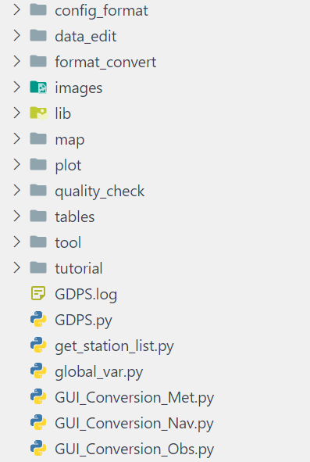 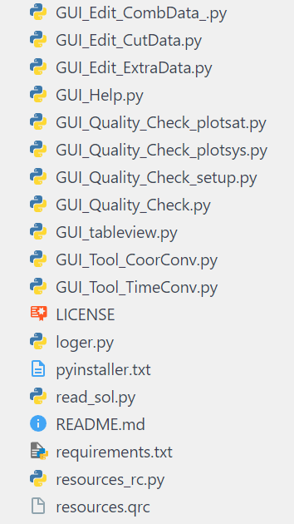

Fig. 1 "\src" folder directory structure

**Step 2:** Execute the installation command (pip install -r requirements.txt) through the console. Fig. 2 shows the input in the Windows environment.

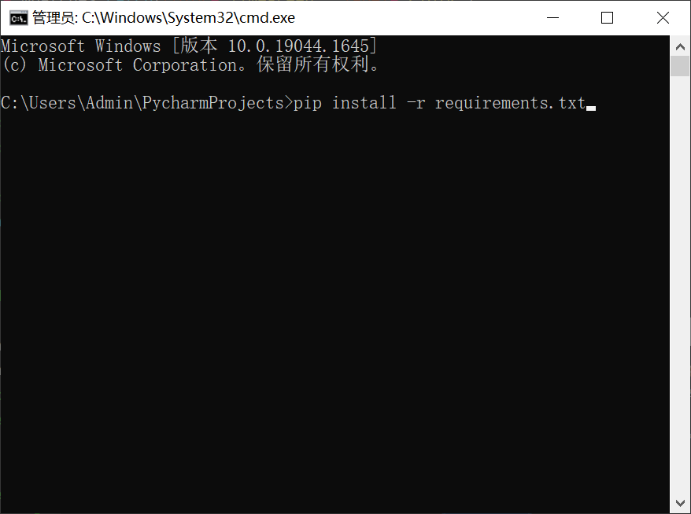

Fig. 2 Installation package list

**Step 3:** Create a project in Pycharm and run GDPS.py. Fig. 3 displays the software interface.

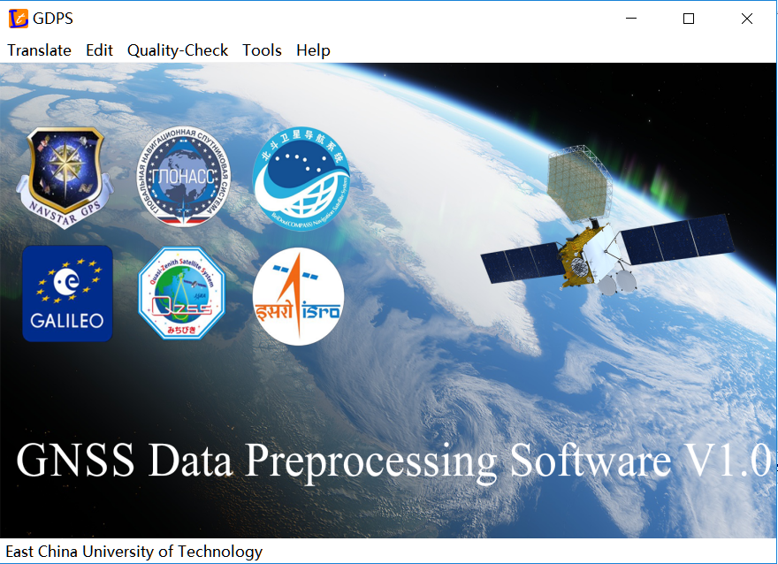

Fig. 3 GDPS main interface

**4 Software and tools instructions**

GDPS software mainly includes four functional modules: format translation, data editing, quality checking, and auxiliary tools, as shown in Fig.4.



Fig. 4 Software functional modules

4.1 Format translation

The format translation module realizes the conversion of GNSS data between RINEX 2.11 and 4.01 versions. According to the file type classification, this module deals with observation data, ephemerides, and meteorological data. Users import the input file, select the corresponding RINEX version, and set the output path. Finally, click "Execute" to execute the conversion task.

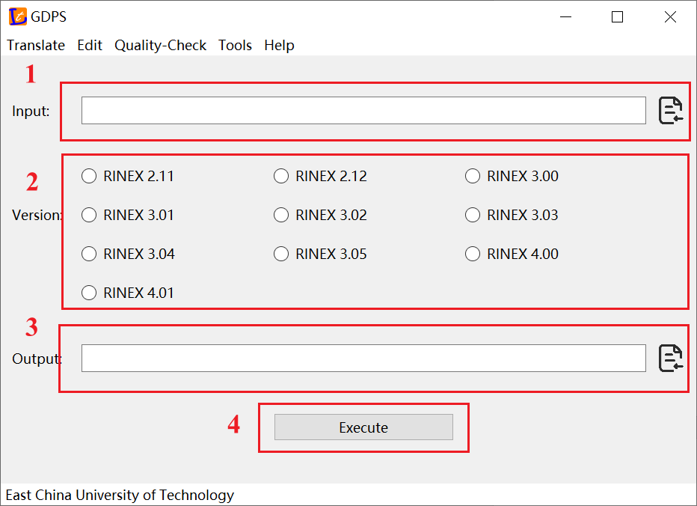

Fig. 5 Format translation module interface

Due to differences in observation code among different versions of RINEX, it is necessary first to determine the priority of observation encoding. Table 1 shows the priority relationship of the observation code for GDPS software.

Table 1 Priority relationship of observation code

|  |  |  |  |
| --- | --- | --- | --- |
| System | Band | Type | priority order |
| GPS | L1 | C | C S L X |
| P | P W Y M |
| L / D / S | P W C S L X Y M N |
| L2 | C | C D S L X |
| P | P W Y M |
| L / D / S | P W C D S L X Y M N |
| L5 | C / L / D / S | I Q X |
| GLONASS | G1 | C | C |
| P | P |
| L / D / S | P C |
| G2 | C | C |
| P | P |
| L / D / S | P C |
| G3 | C / L / D / S | I Q X |
| Galileo | E1 | C / L / D / S | B C X Z A |
| E5a | C / L / D / S | I Q X |
| E5b | C / L / D / S | I Q X |
| E5(E5a+E5b) | C / L / D / S | I Q X |
| E6 | C / L / D / S | B C X Z A |
| BDS | B1 | C / L / D / S | I Q X |
| B2/B2b | C / L / D / S | I Q X D P Z |
| B3/B3A | C / L / D / S | I Q X D P Z |
| SBAS | L1 | C / L / D / S | C |
| L5 | C / L / D / S | I Q X |

4.2 Data editing

Due to the specific needs of different users, some data record contents need to be modified. The data editing module is concerned with data segmentation, splicing, and extraction to assist users in editing the file structure of observation data. Among them, data splitting is to cut the data of the whole observation period into several periods; data extraction is to access observation values according to the information of frequency code, satellite system, pseudo-random code, sampling interval, and observation duration; and data splicing is to merge several periods into one data.

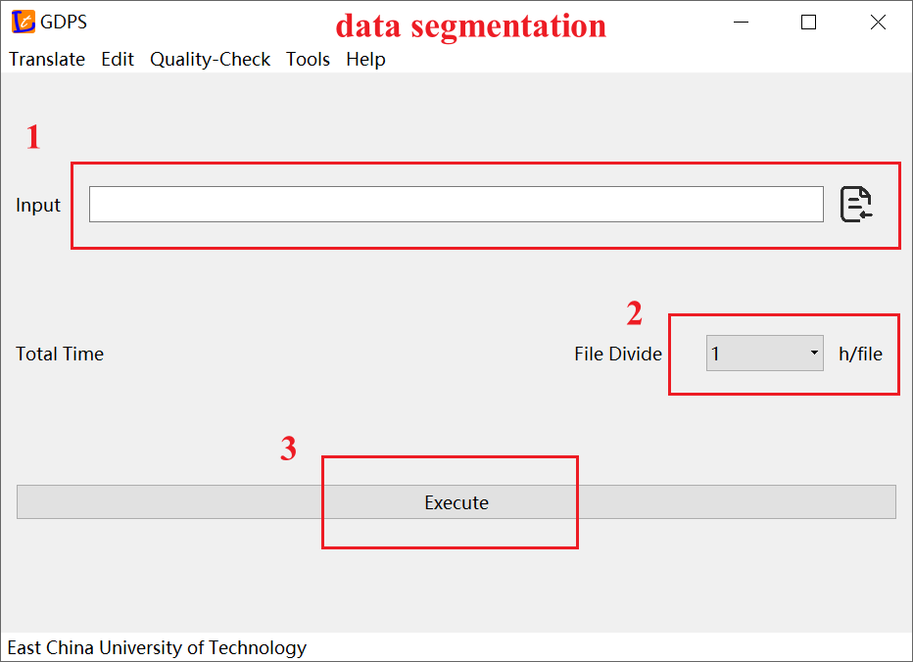 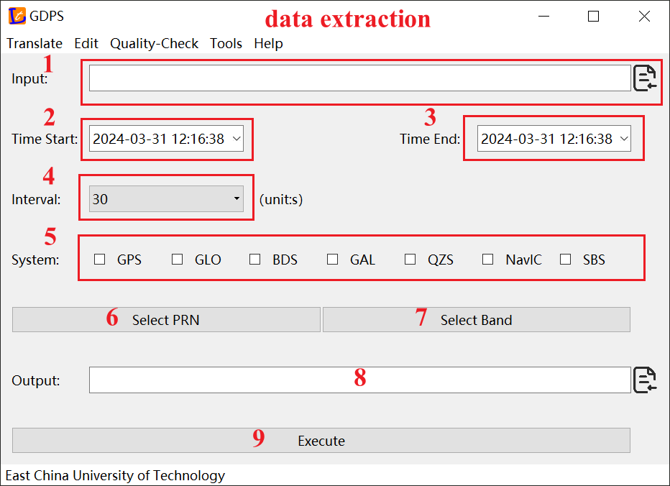

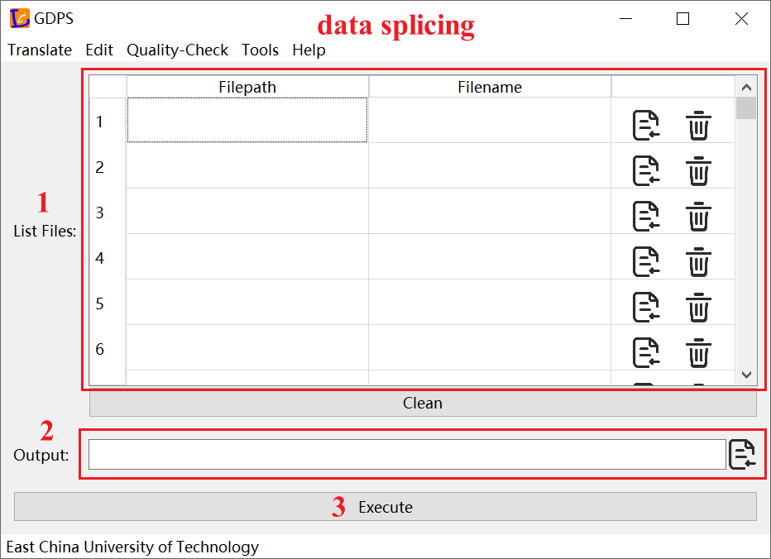

Fig. 6 Data editing module interface

4.3 Quality checking

The quality of observation data is the guarantee of subsequent high-quality positioning services. The quality checking module aims to achieve the calculation and visual analysis of the observation data quality checking indexes. The quality checking results include summary information, carrier-to-noise ratio, ionospheric delay rate, pseudorange/carrier phase multipath, pseudorange/carrier phase noise, data integrity/saturation rate, and single point positioning.

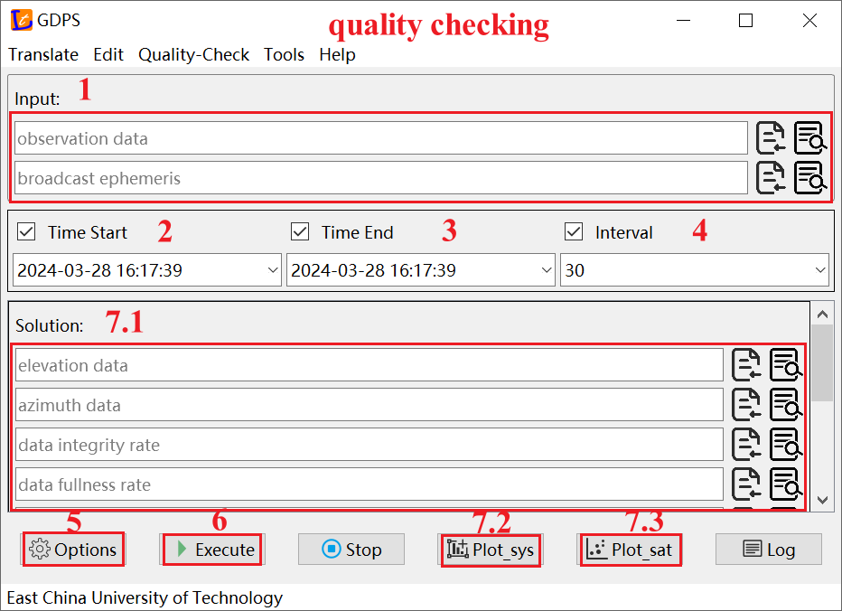 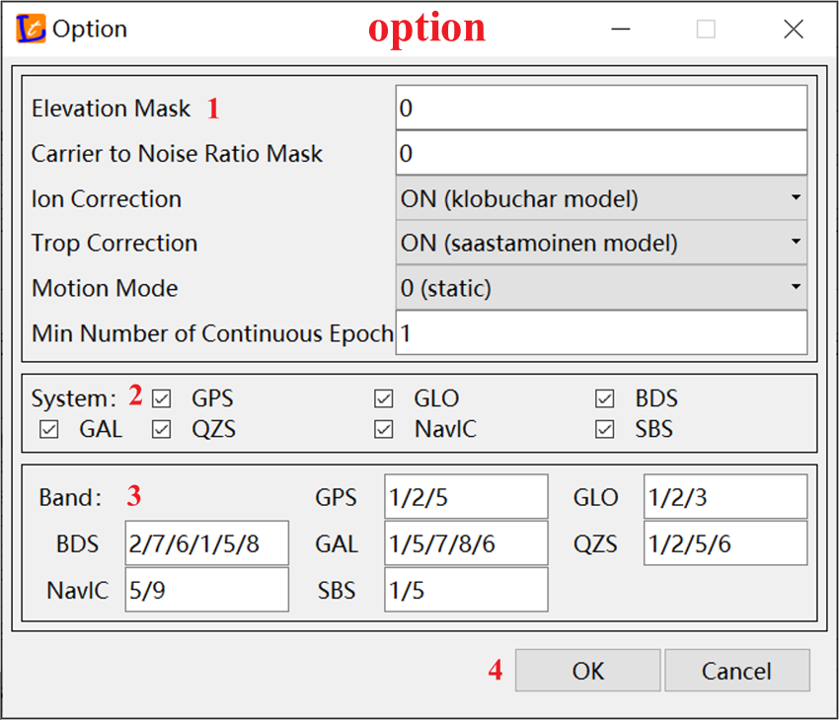

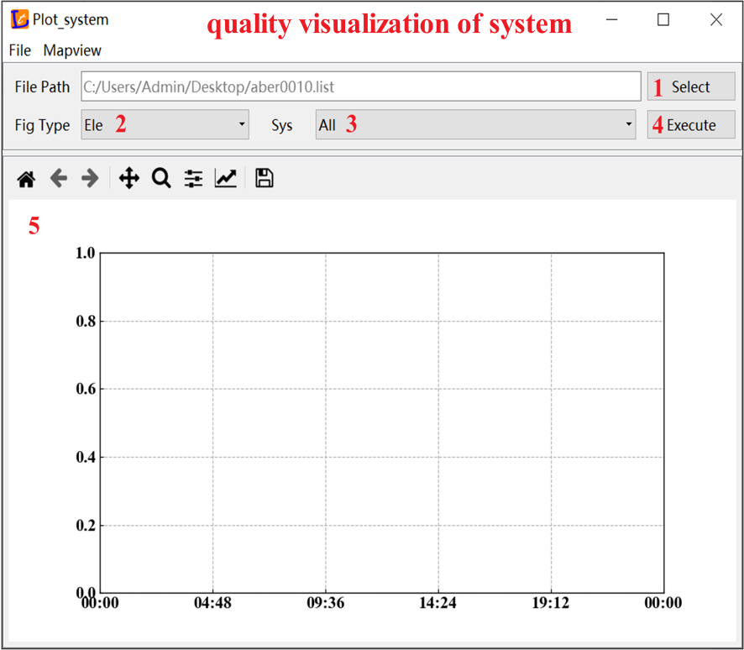 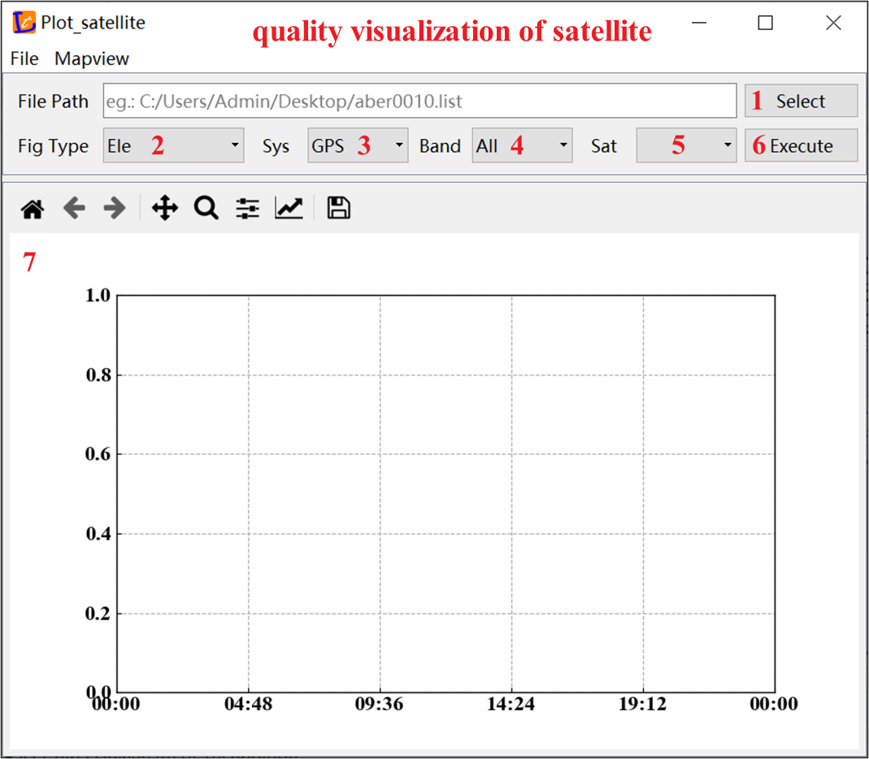

Fig. 7 Quality checking module interface

4.4 Auxiliary tools

GDPS provides some auxiliary tools to improve the efficiency of data processing and result analysis. The auxiliary tool module mainly includes functions such as PPP service, coordinate transformation, and time transformation. The PPP service module provides several popular online PPP service interfaces, such as APPS, AUSPOS, CSRS-PPP, GAPS, magicGNSS, Net _ Diff, OPUS, and RTX-PP. The coordinate transformation module supports coordinate transformation between XYZ, NEU, and BLH in batch processing mode. The time transformation module provides the conversion function of the year/month/day/minute/second format to the Julian day, simplified Julian day, Day of Year (DOY), GPS week day and week second, and BDS week day and week second.

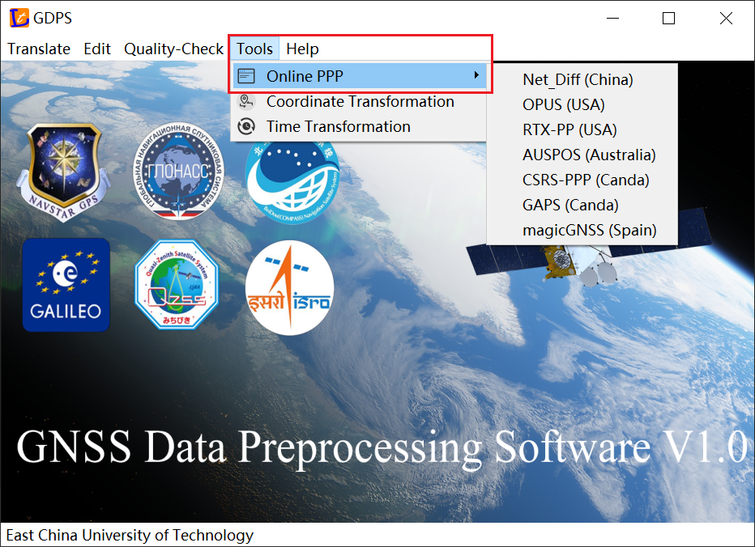

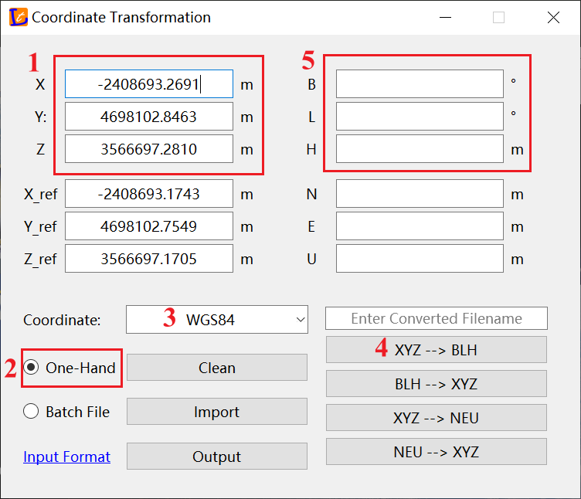

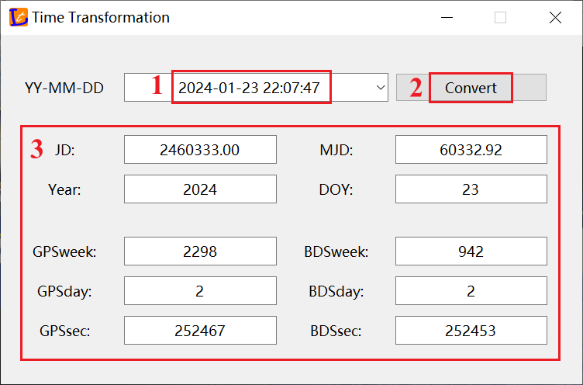

Fig. 8 Auxiliary tools module interface

**5 Software operation**

5.1 Format translation operation

In the format translation module, users can convert the corresponding version from 3.05 to 2.11, convert the satellite system from multi-GNSS to GPS, GLONASS, Galileo, and SBAS systems, and convert the observation encoding type from a separate system to an integrated encoding.

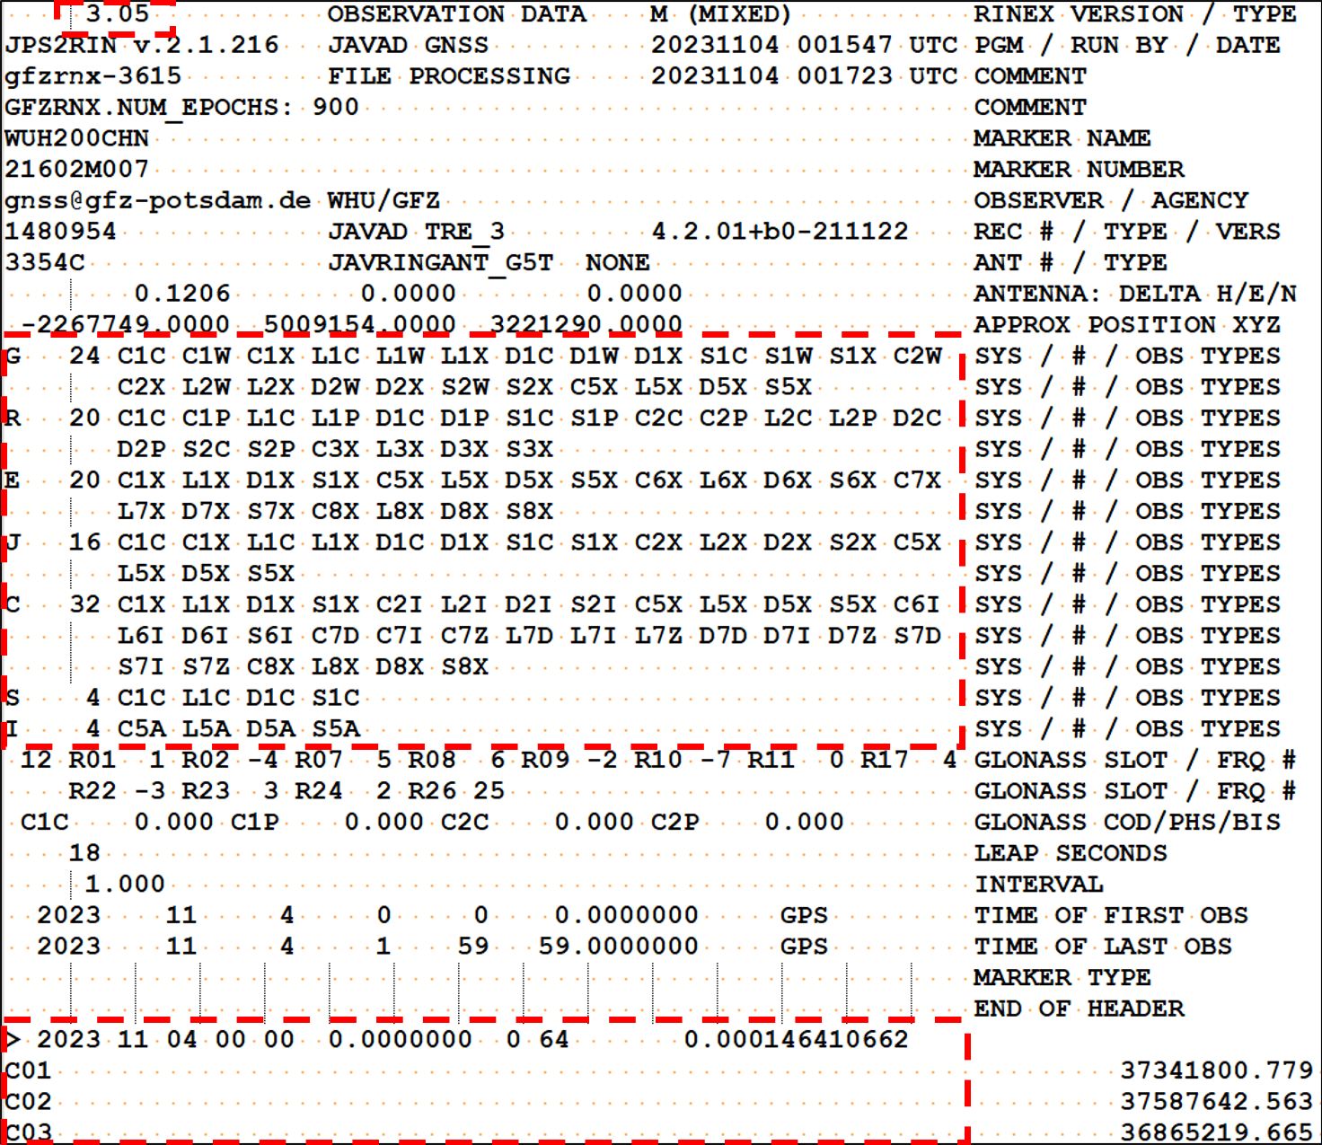 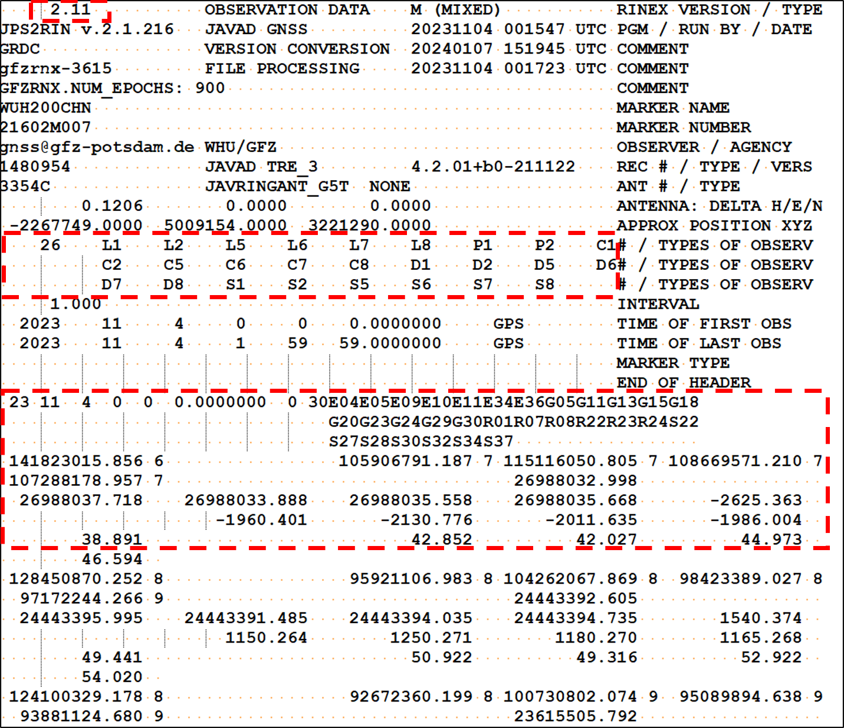

Fig. 9 Format translation demonstration

5.2 Data editing operation

In the data editing module, users need to batch import multiple sets of observation data to be merged and then click the "Execute" button to perform data merging.



Fig. 10 Data editing demonstration

5.3 Quality checking operation

After importing observation data, broadcast ephemerides, and setting parameters, the software automatically generates a configuration file to start quality inspection calculation. The output results include summary information, carrier-to-noise ratio, ionospheric delay rate, pseudorange/carrier phase multipath, pseudorange/carrier phase noise, data integrity/saturation rate, and single point positioning.



Fig. 11 Quality checking demonstration

Table 2 Output file types

|  |  |
| --- | --- |
| File suffix name | File type |
| azi | azimuth |
| ele | elevation |
| pnoise | pseudorange noise |
| lnoise | carrier phase noise |
| cycleslip | cycle slip marker |
| clkjump | clock jump marker |
| inte | data integrity rate |
| satu | data saturation rate |
| cnr | carrier-to-noise-density ratio |
| iod | ionospheric delay rate |
| pmp | pseudorange multipath |
| lmp | carrier phase multipath |
| vis | visible satellite markers |
| pos | single point positioning |
| list | output file list |
| sat | satellite list |
| sum | summary information |

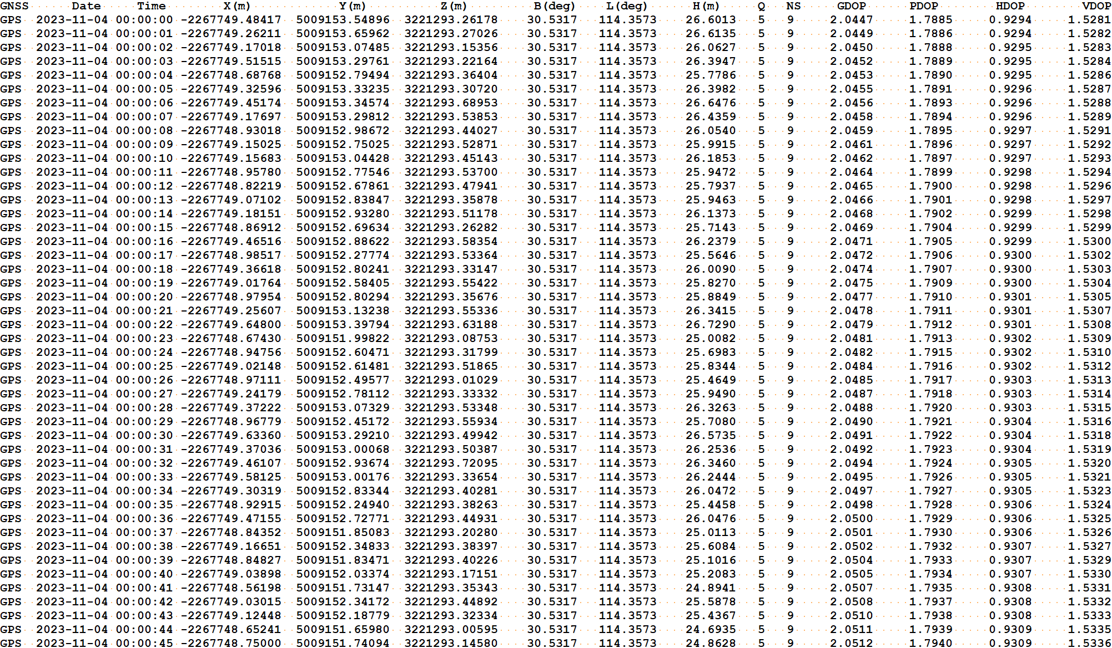

Fig. 12 position information file

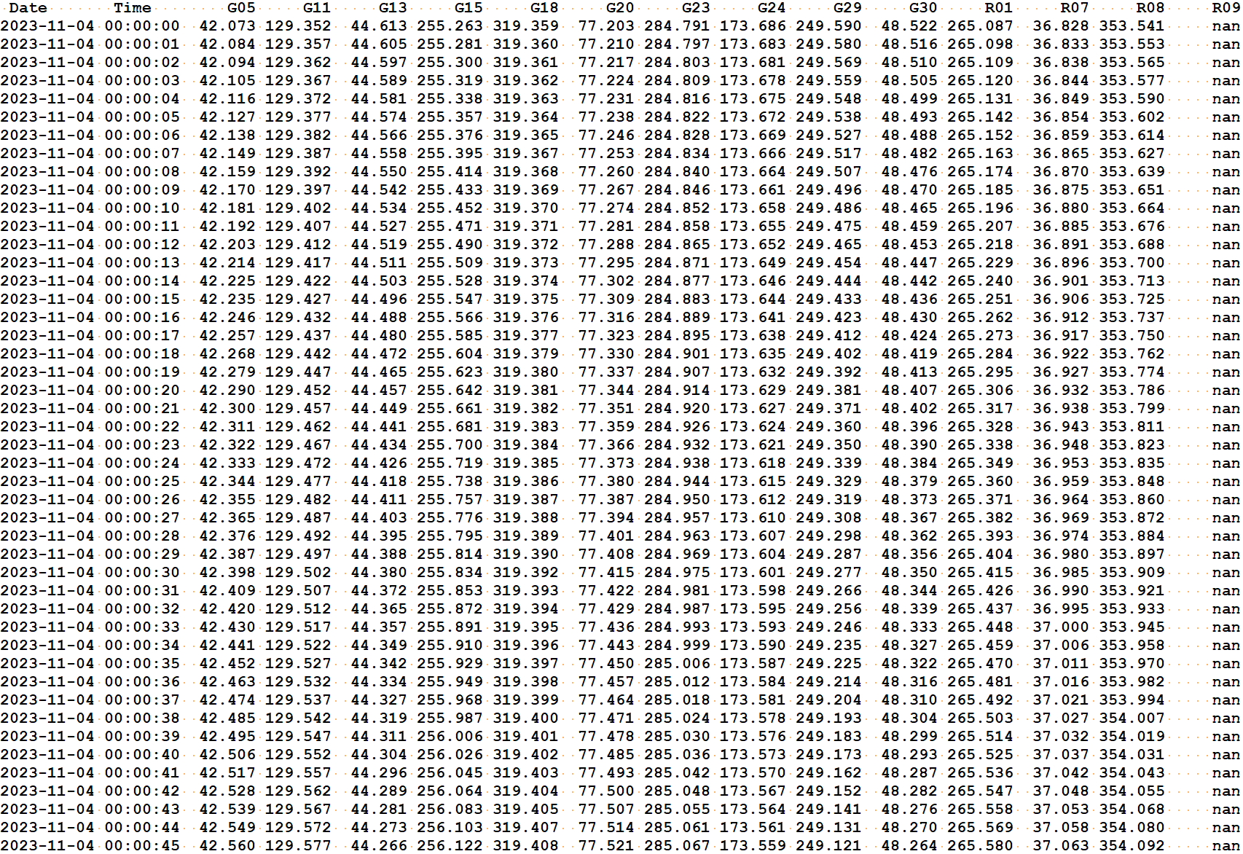

Fig. 13 azimuth file

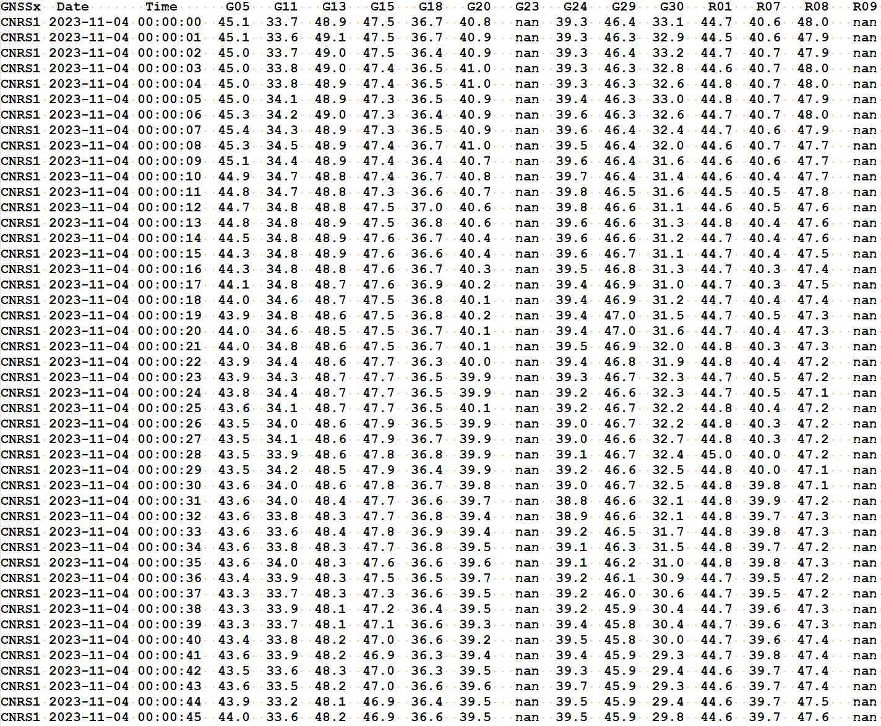

Fig. 14 C/N0 file

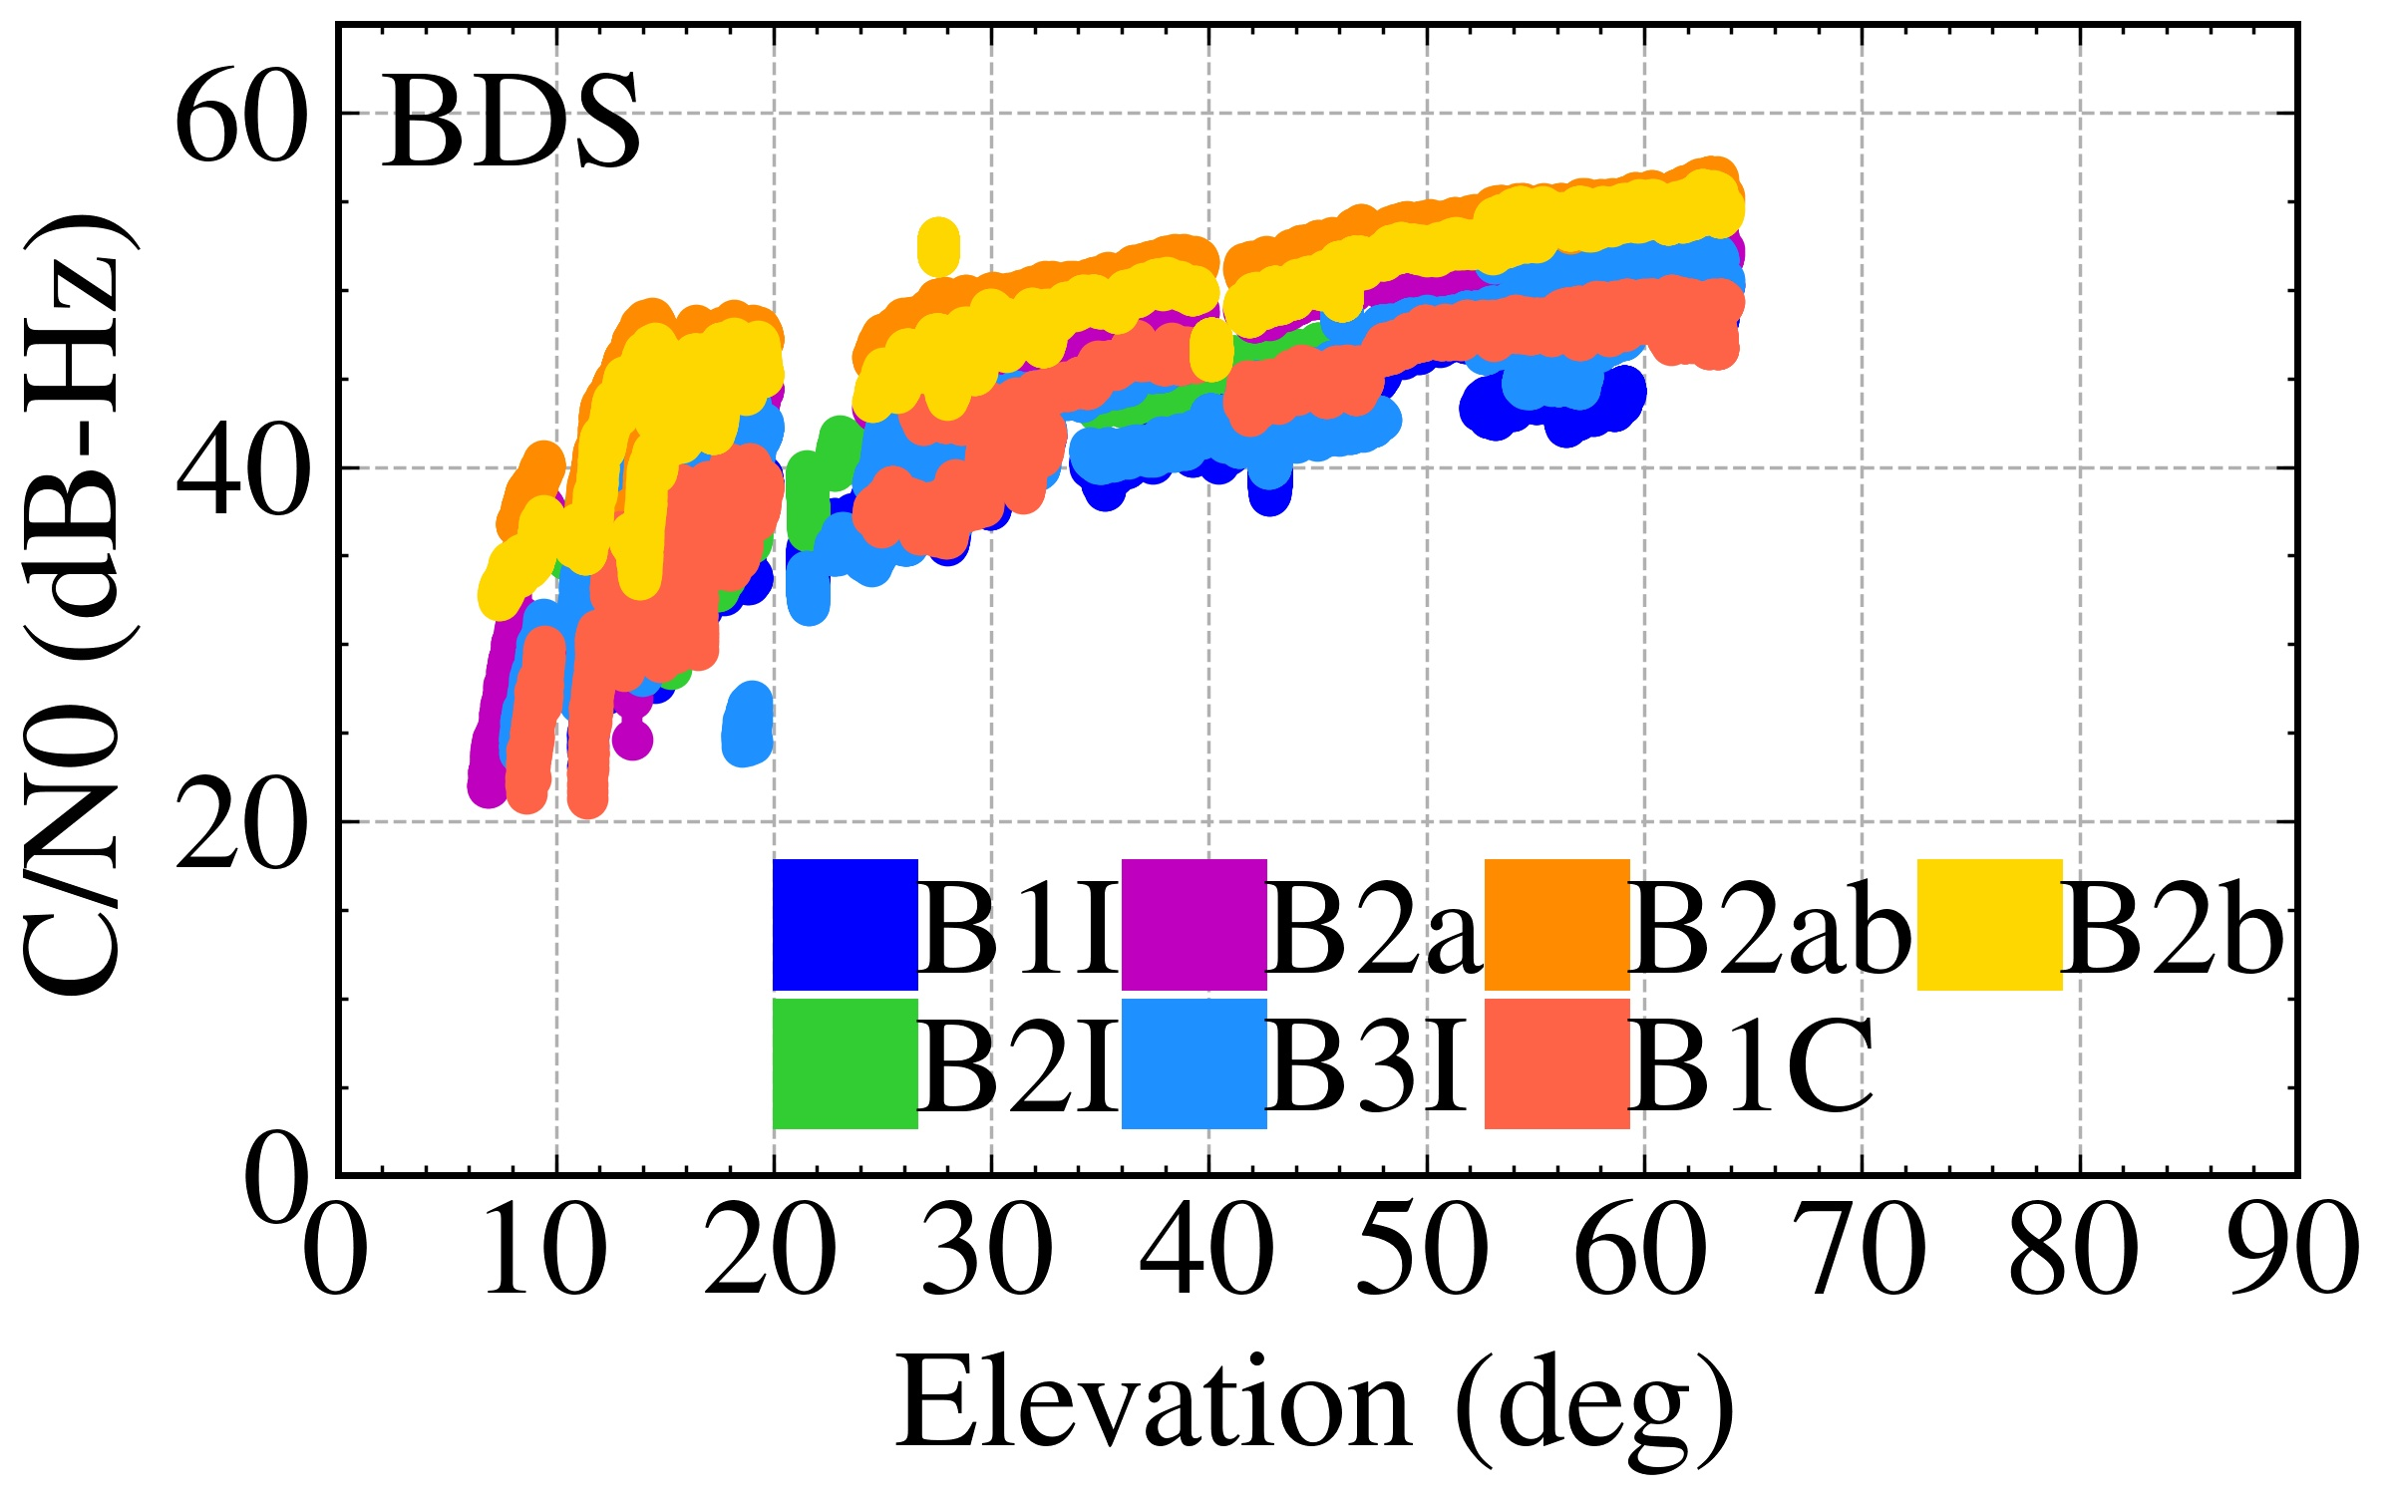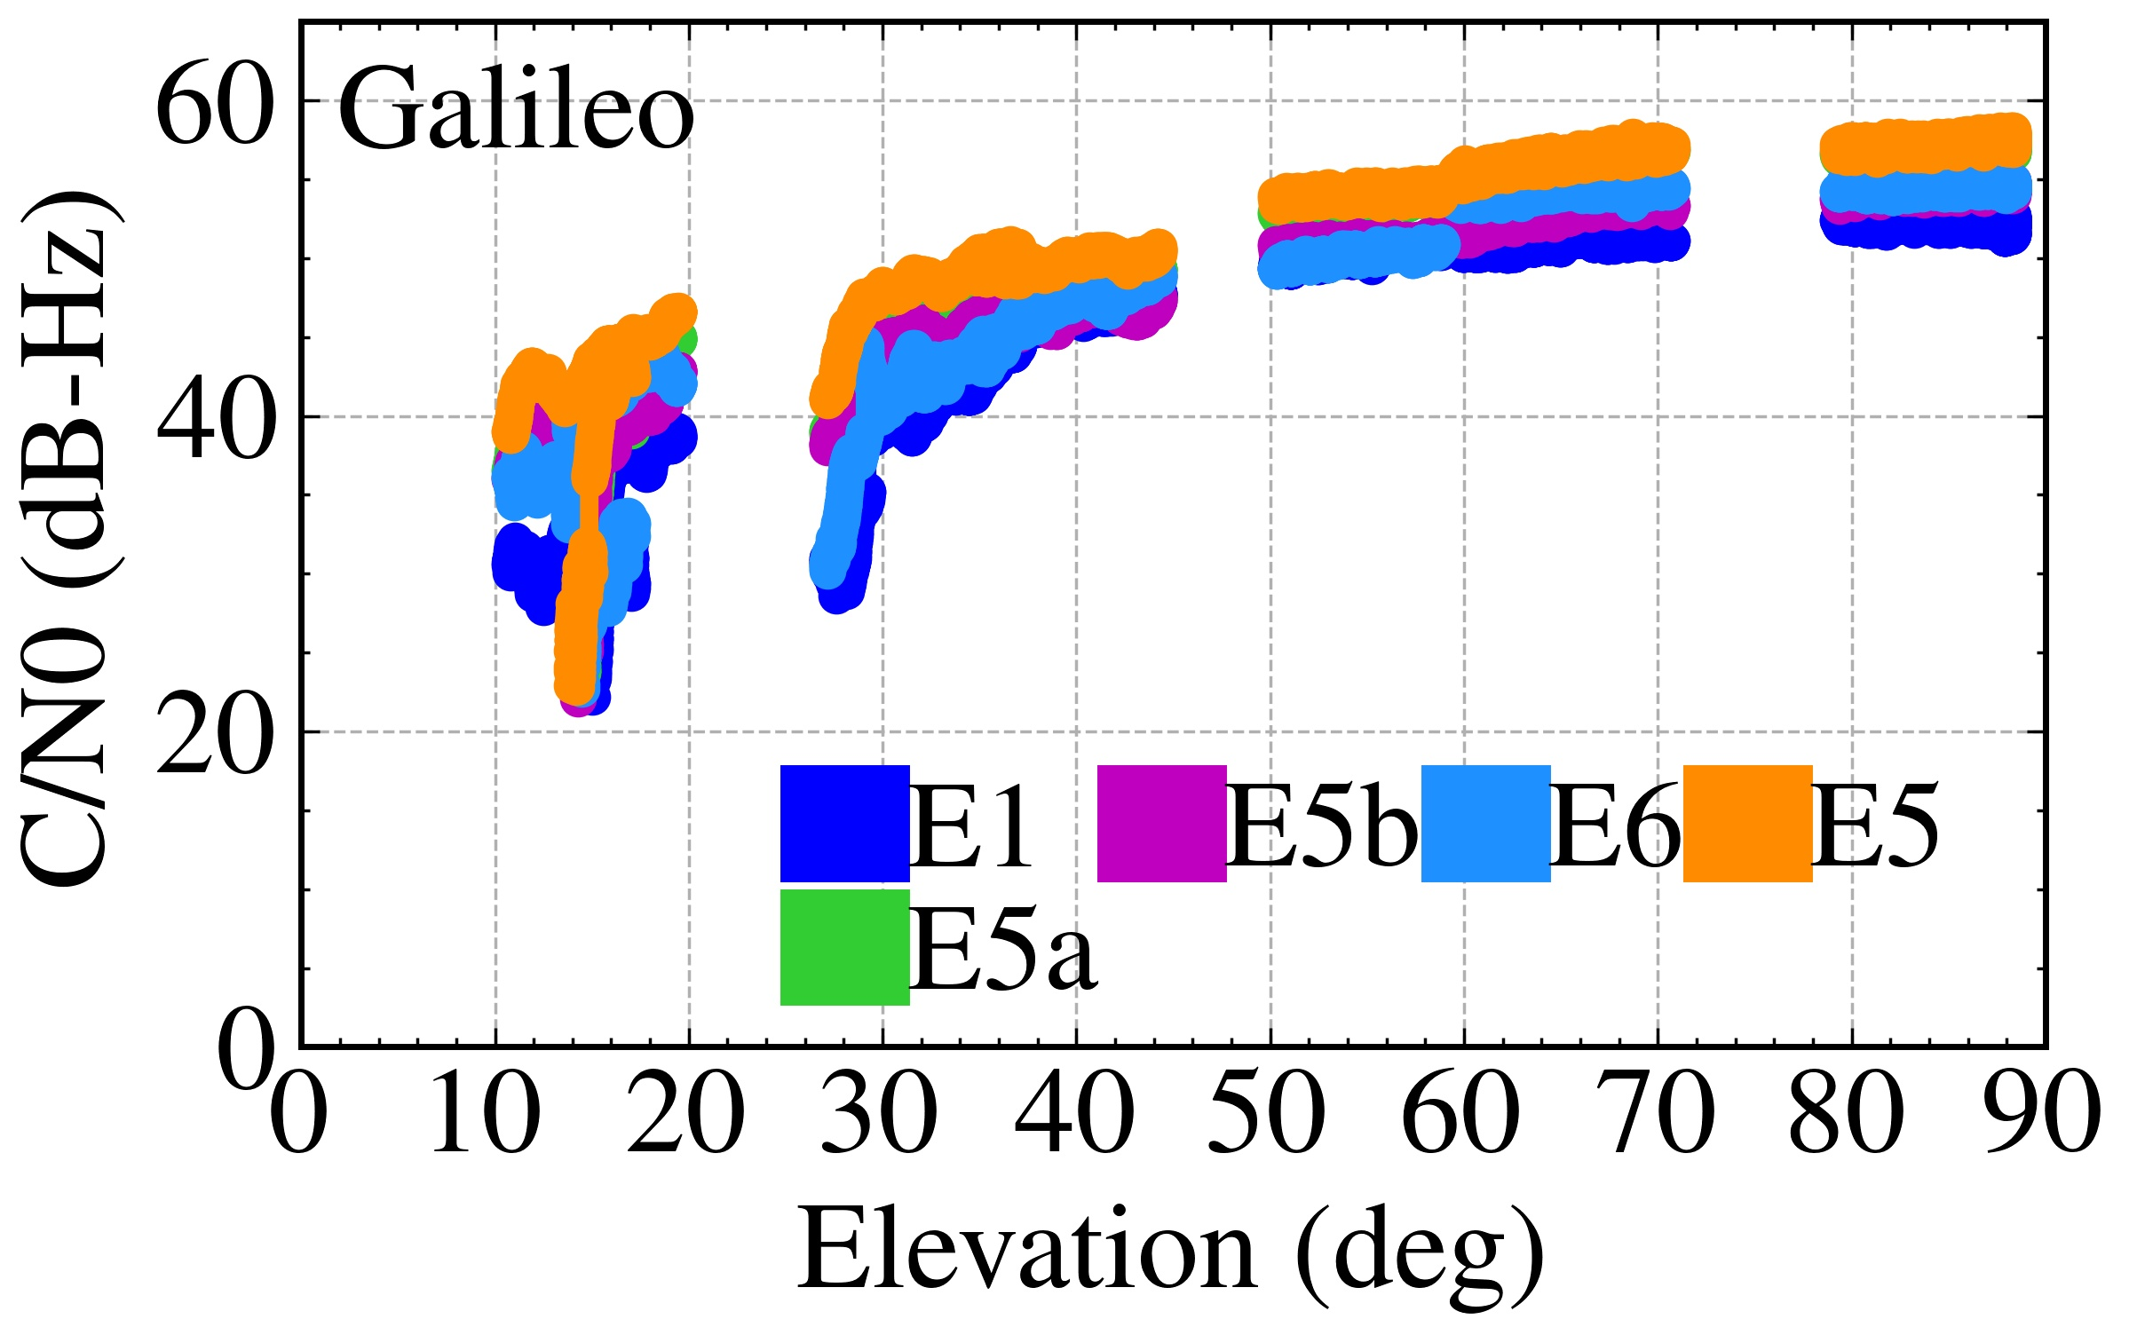

Fig. 15 Carrier-to-noise ratio at different frequencies for two systems

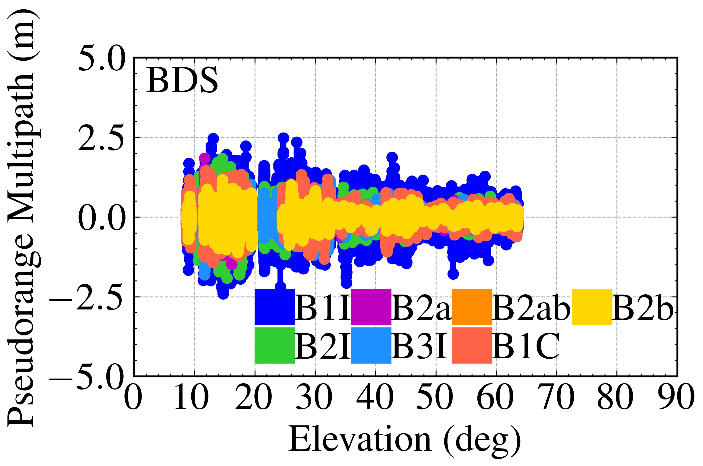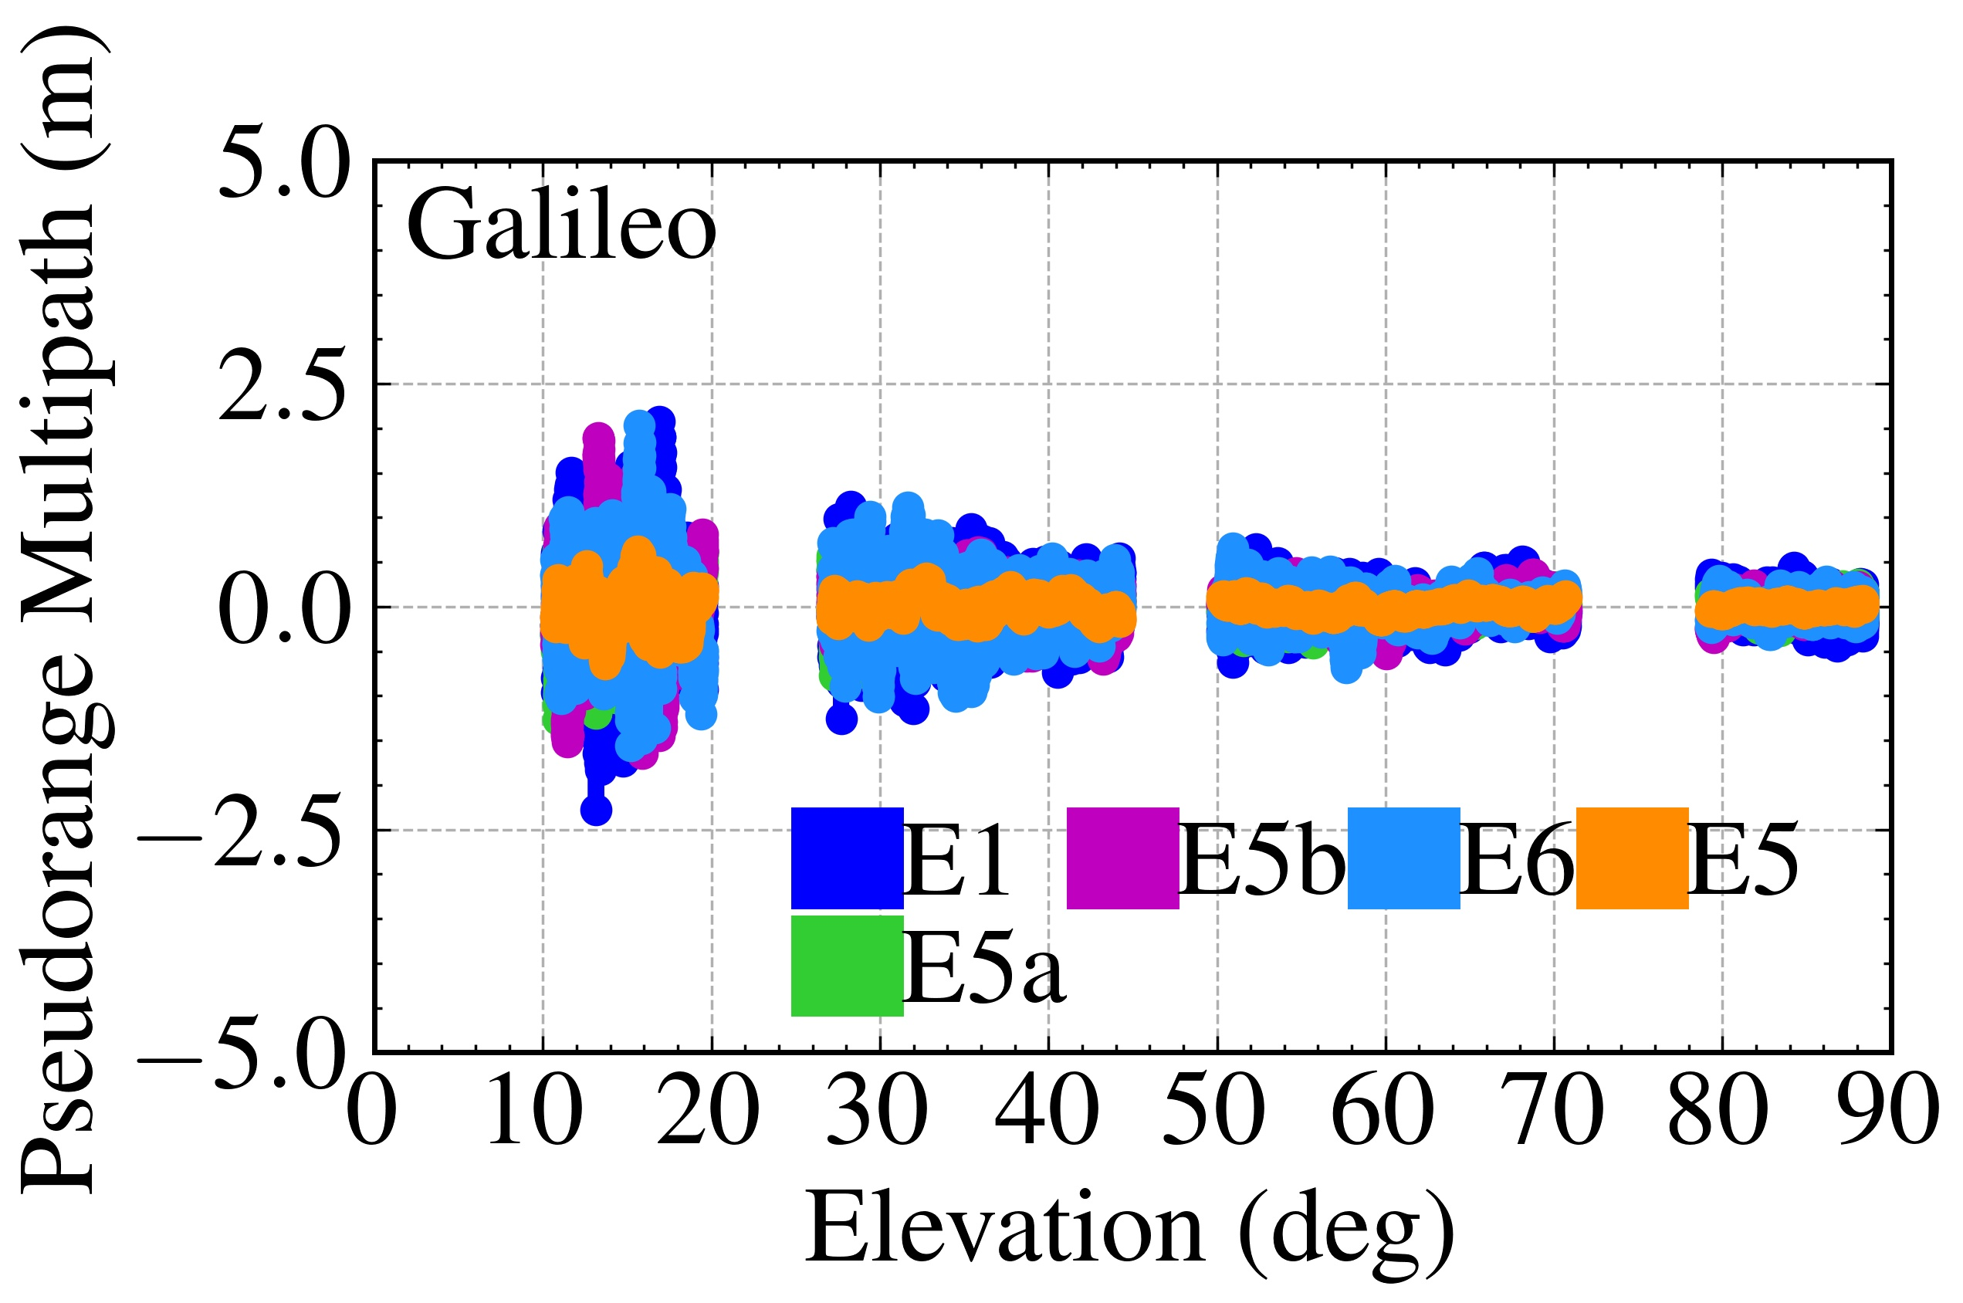

Fig. 16 Pseudorange multipath variation at different frequencies for two systems

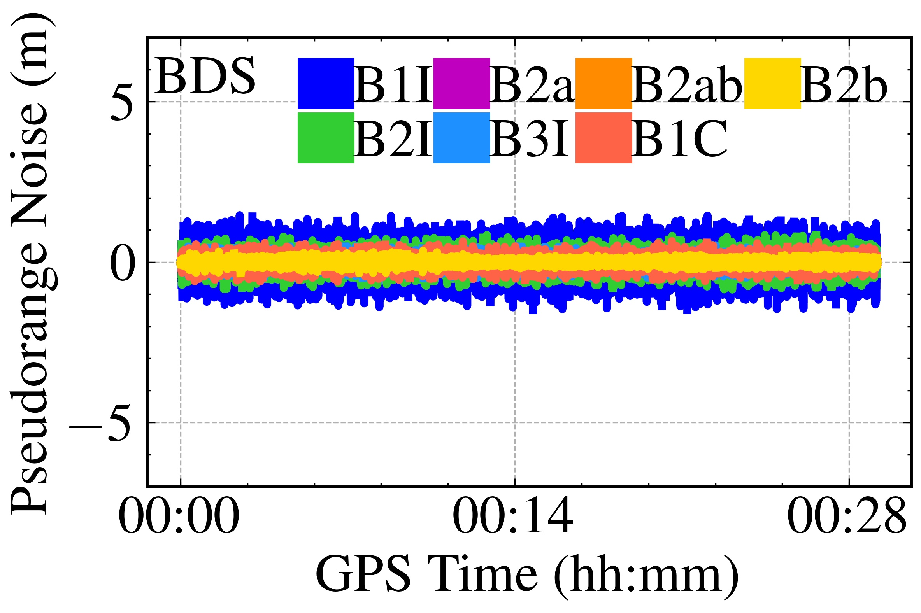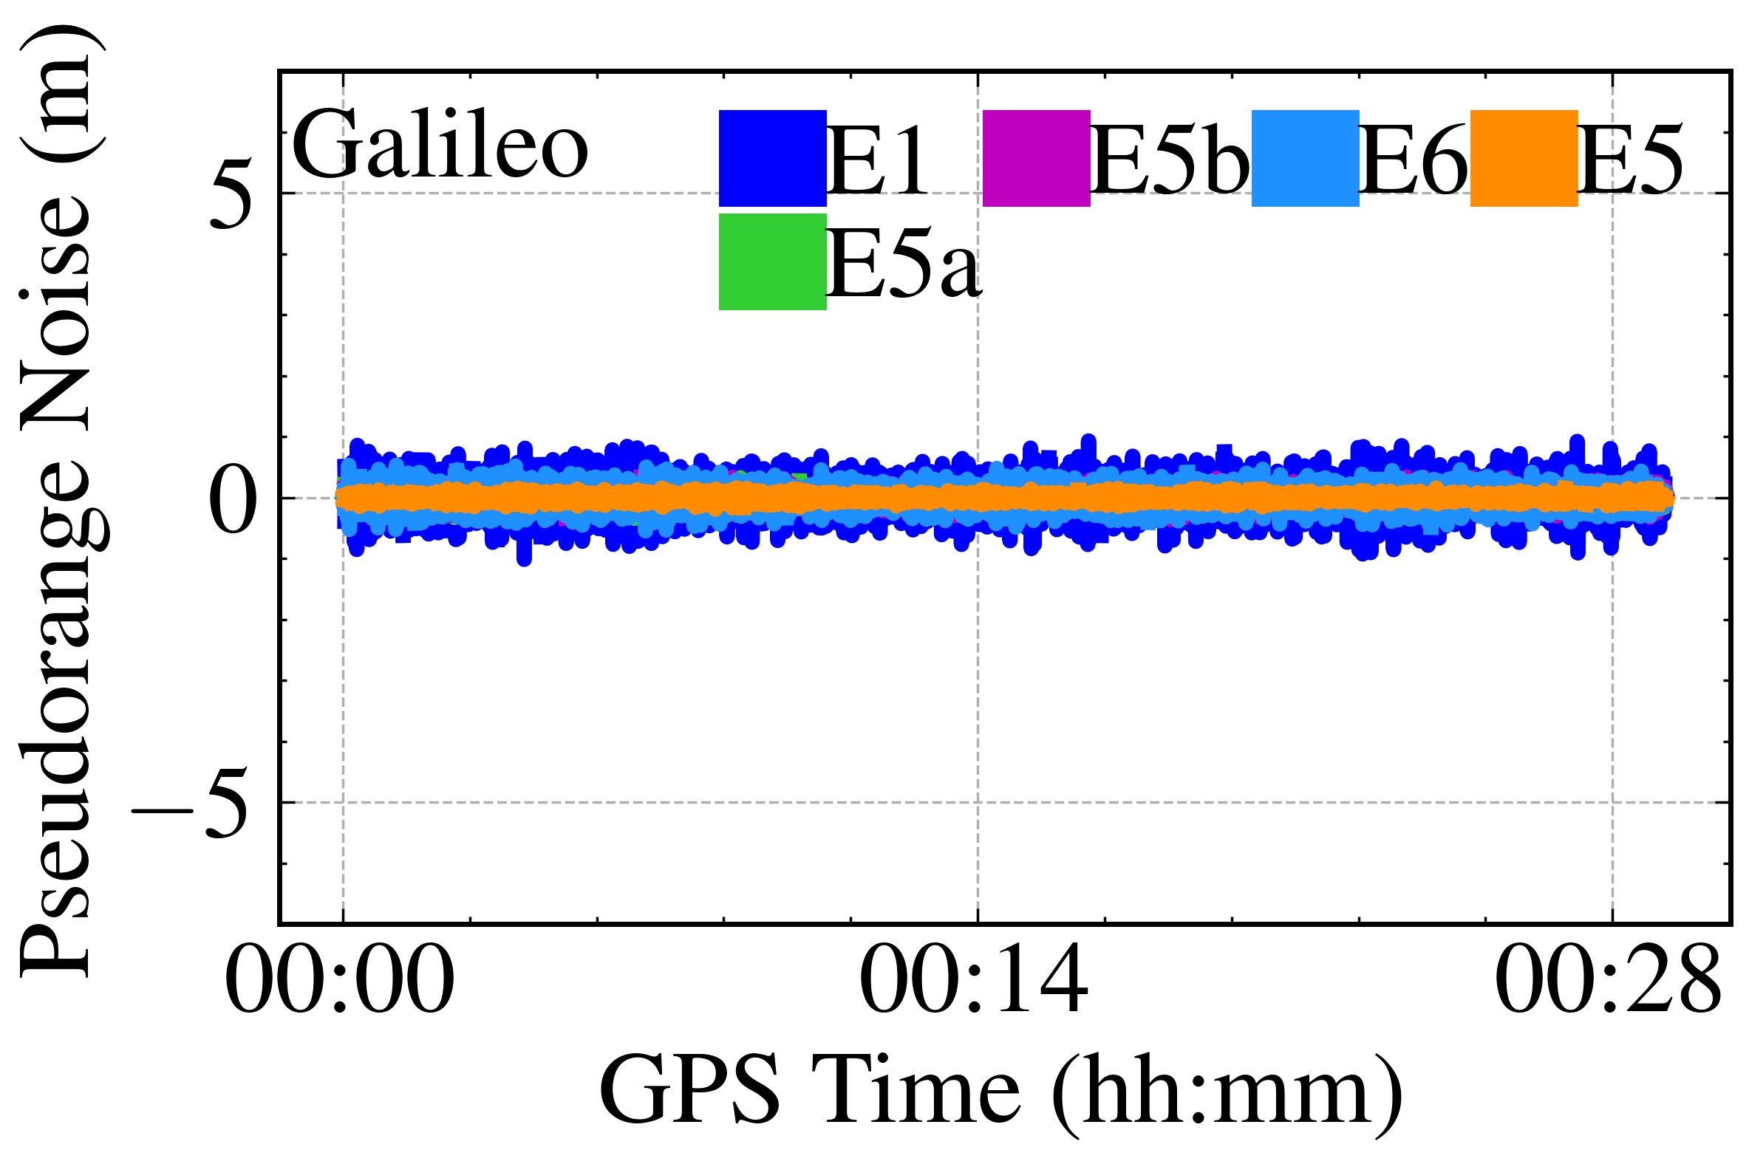

Fig. 17 Pseudorange observation noise sequences at different frequencies for two systems

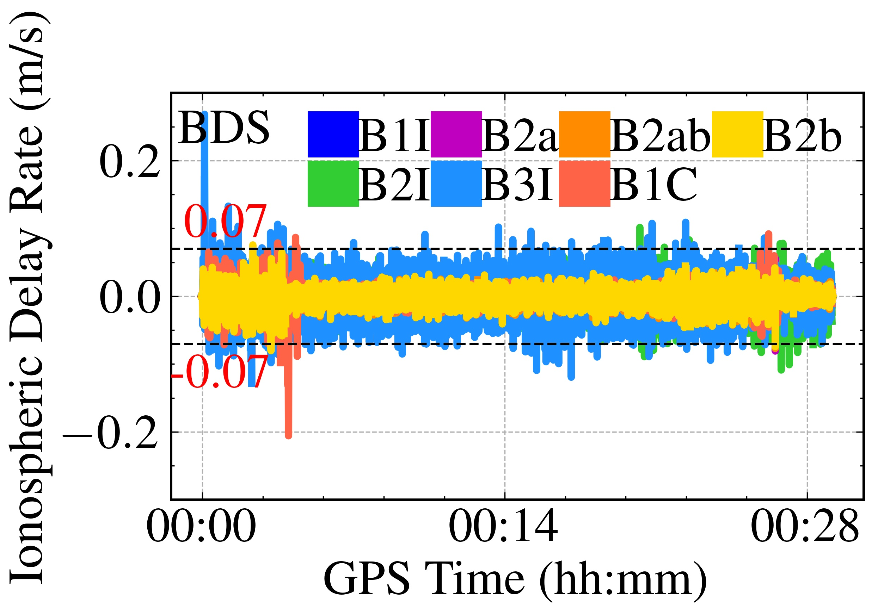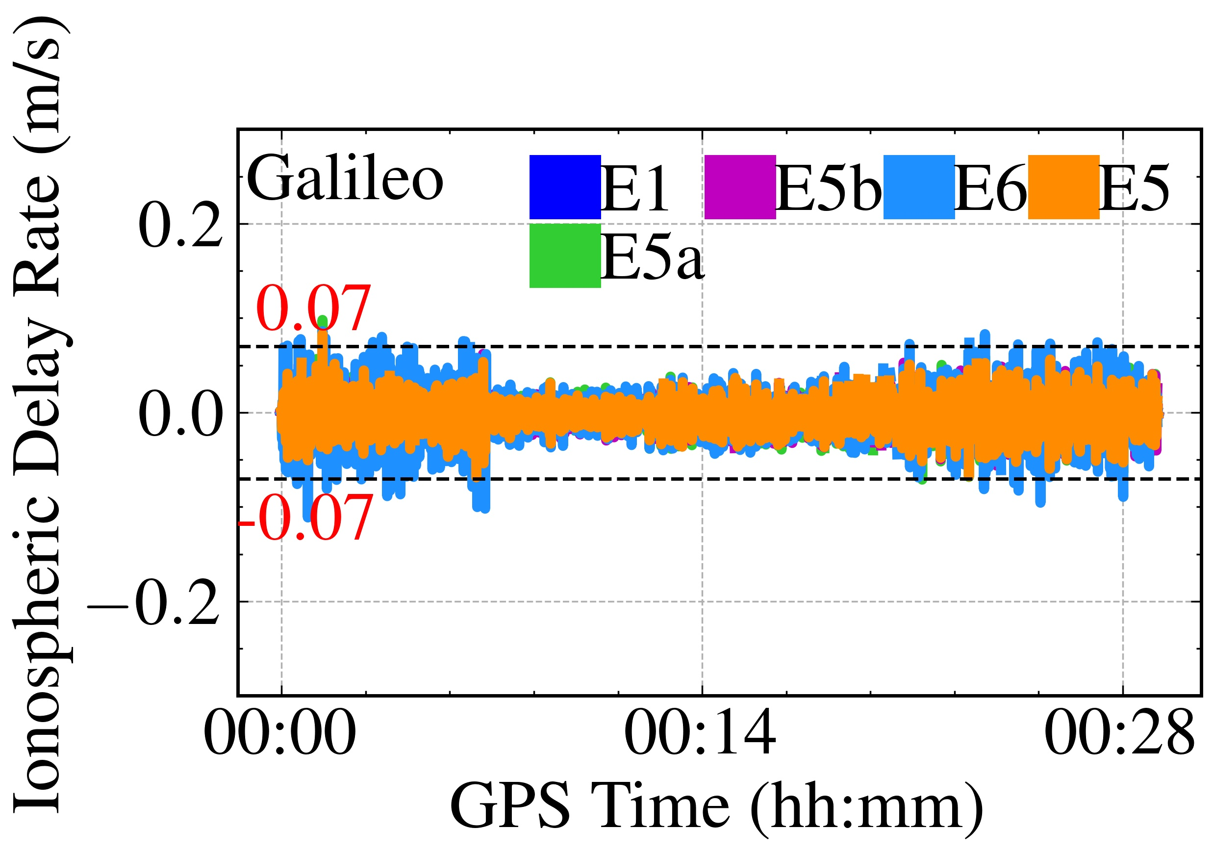

Fig. 18 Ionospheric delay rate at different frequencies for two systems

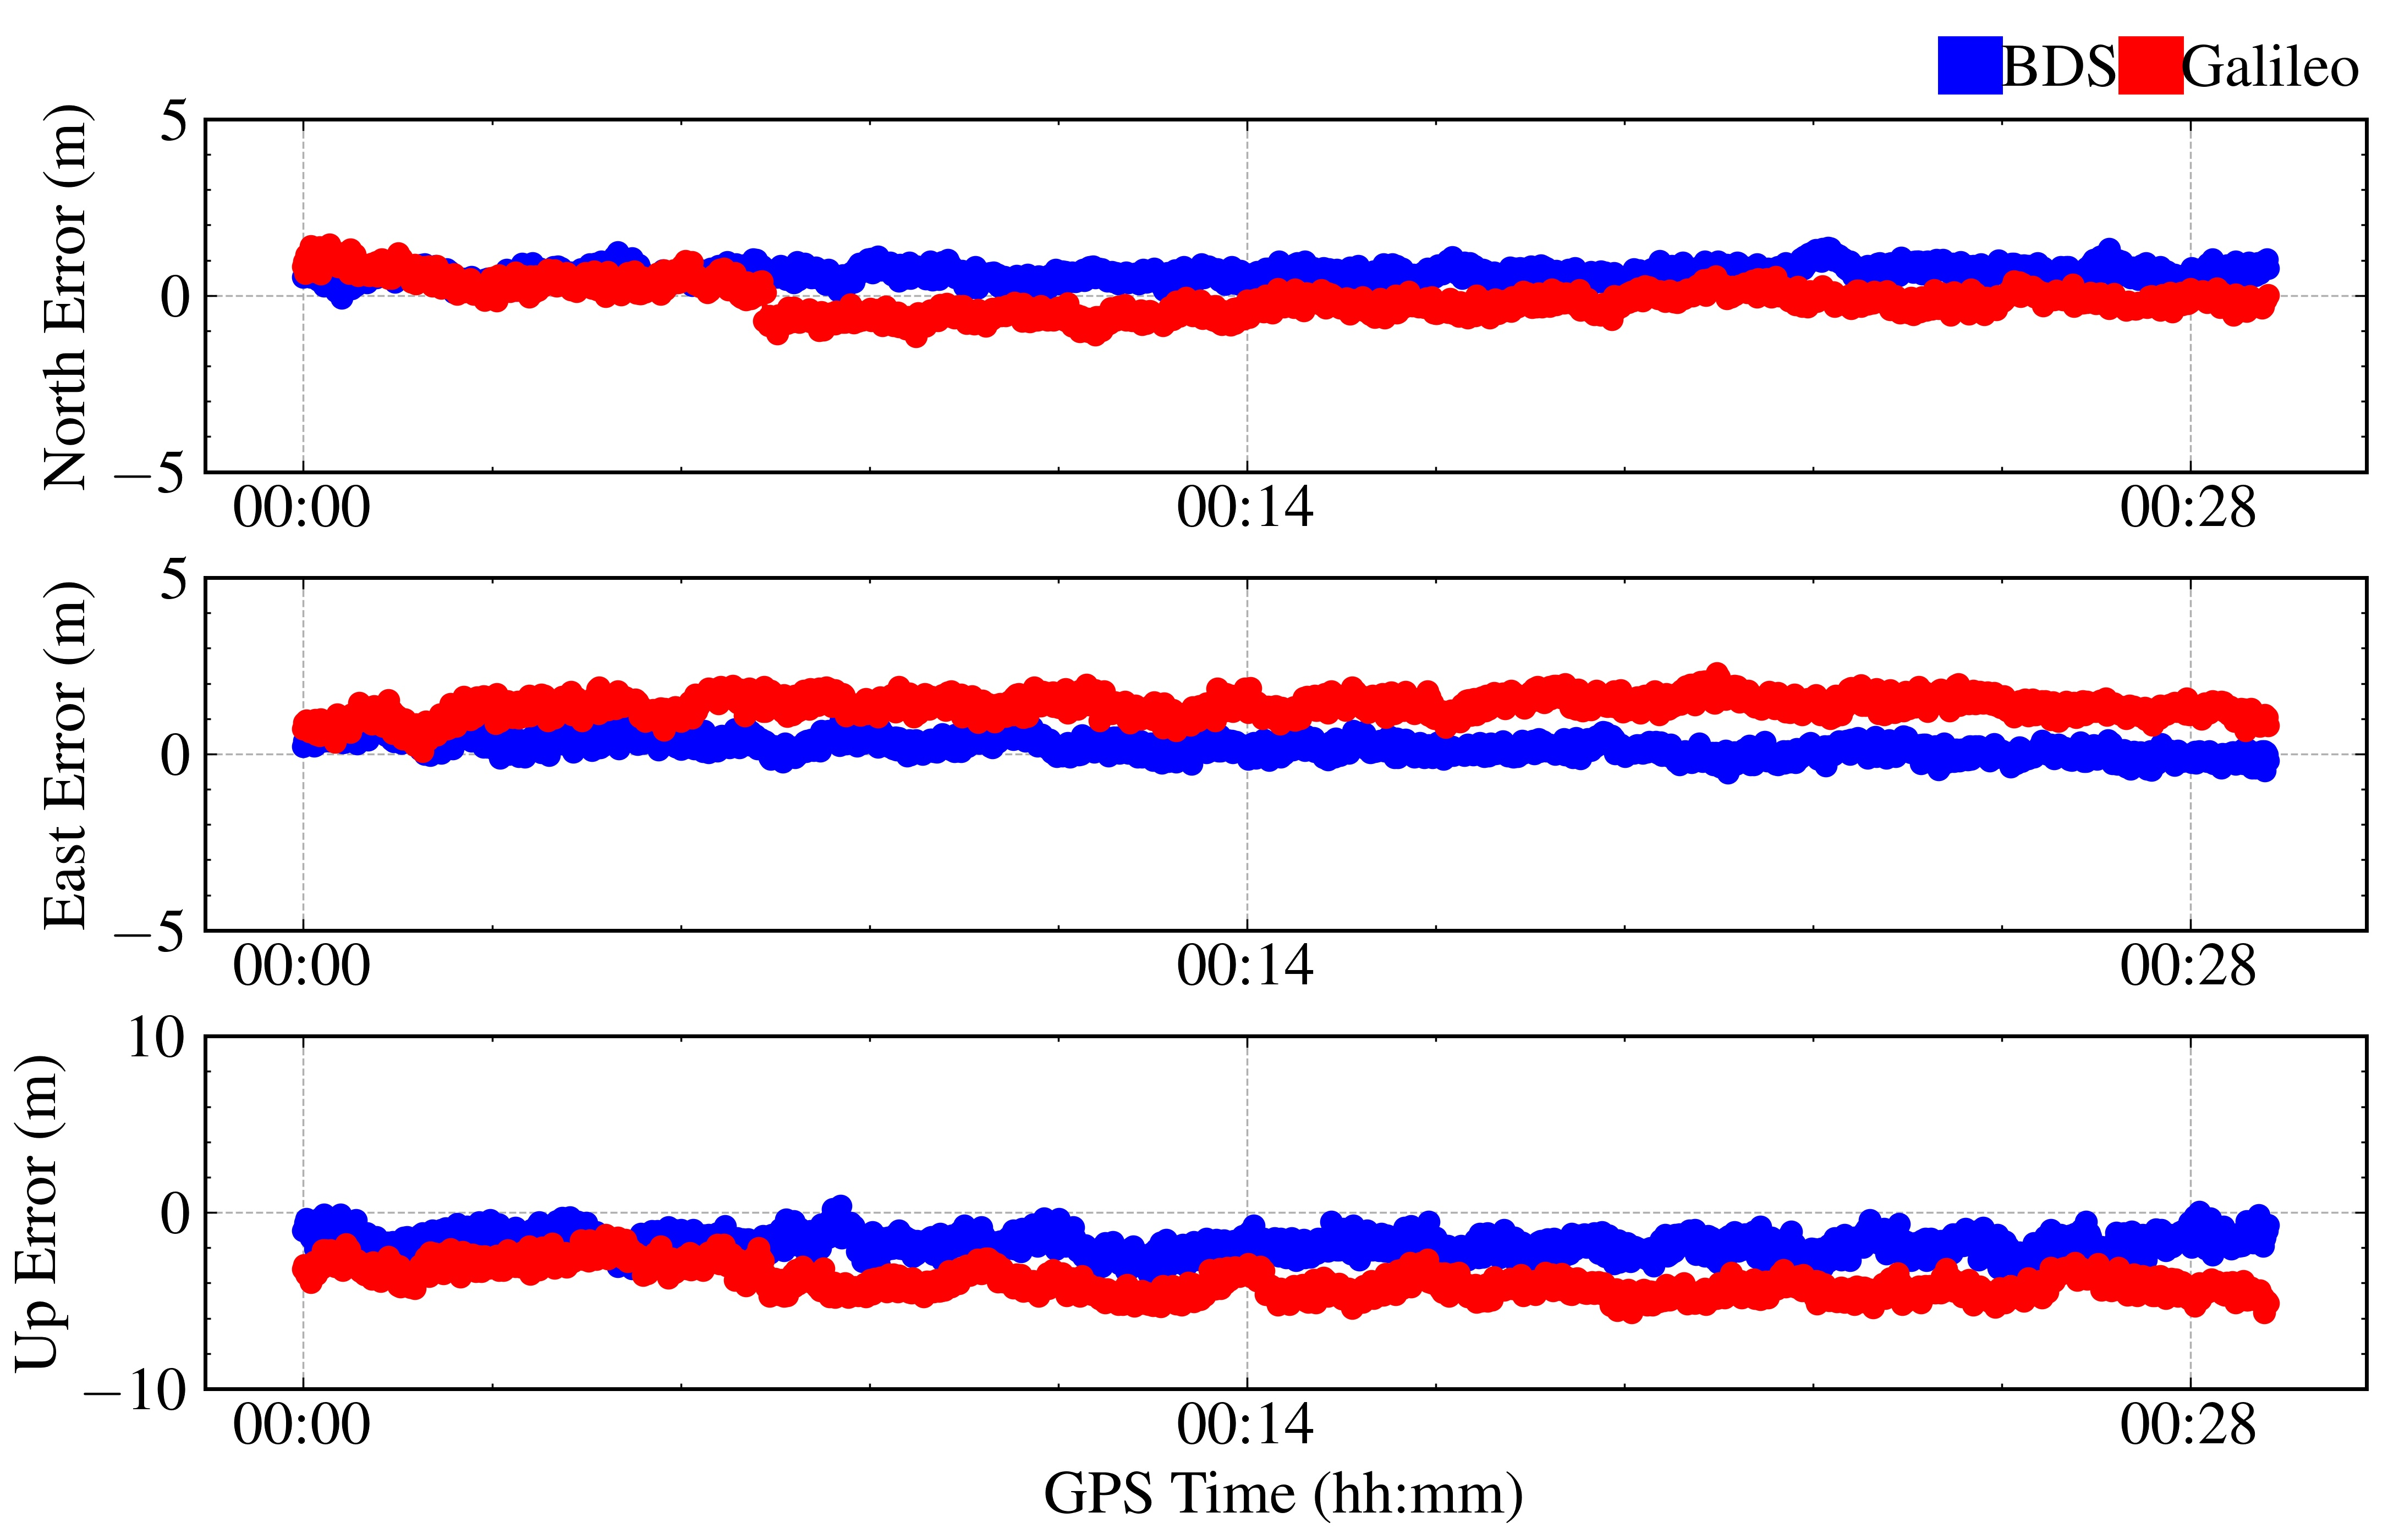

Fig. 19 Single point positioning results for two systems

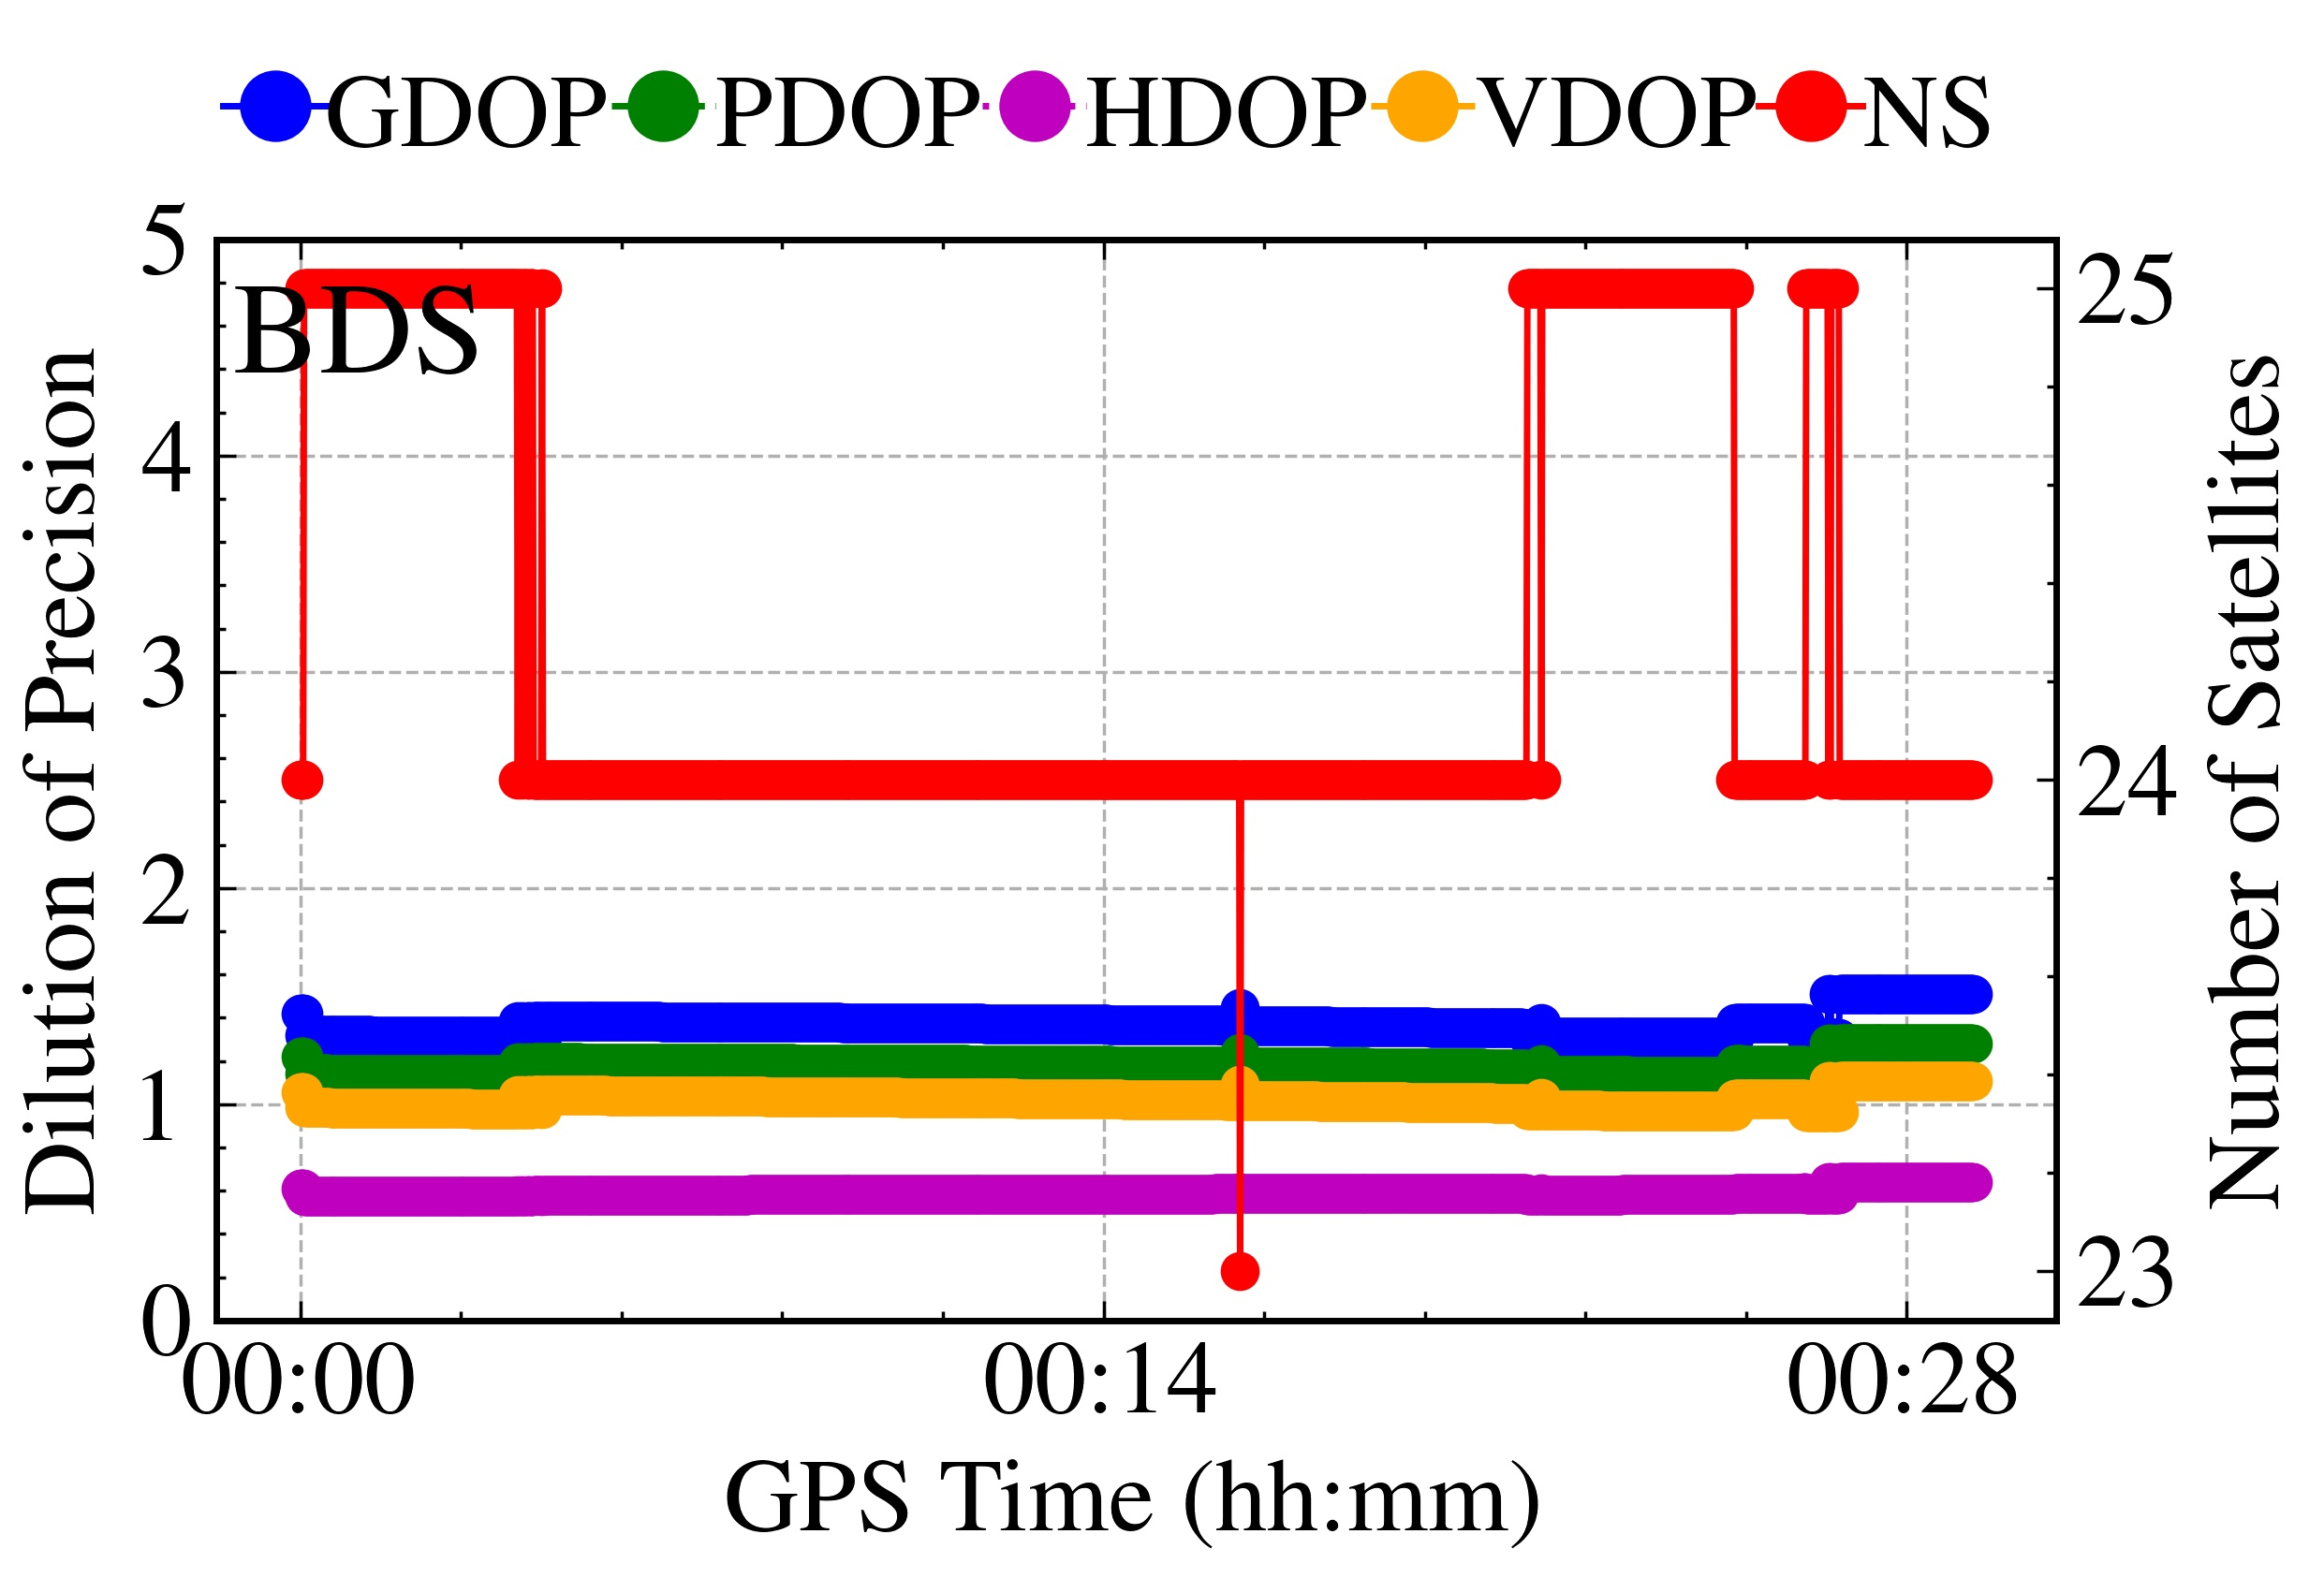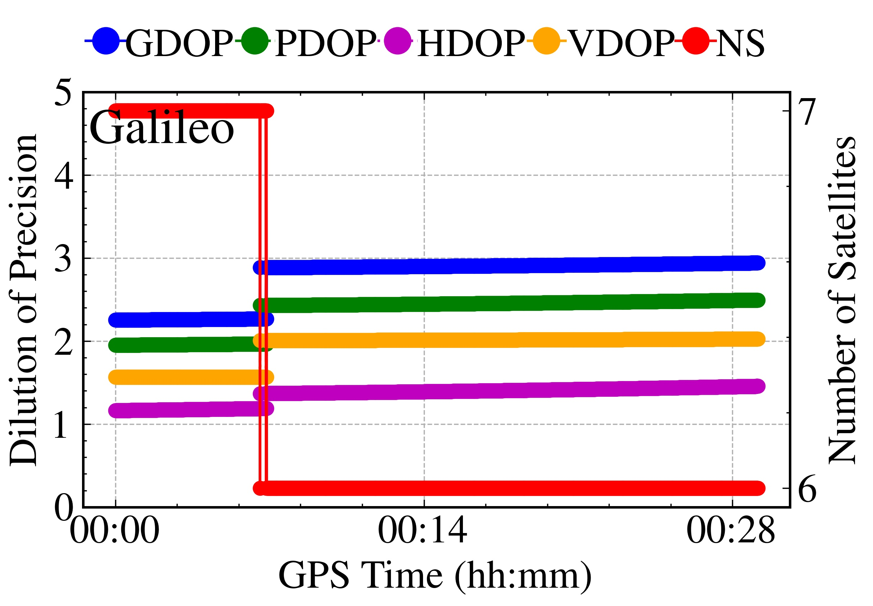

Fig. 20 Number of visible satellites and DOP for two systems

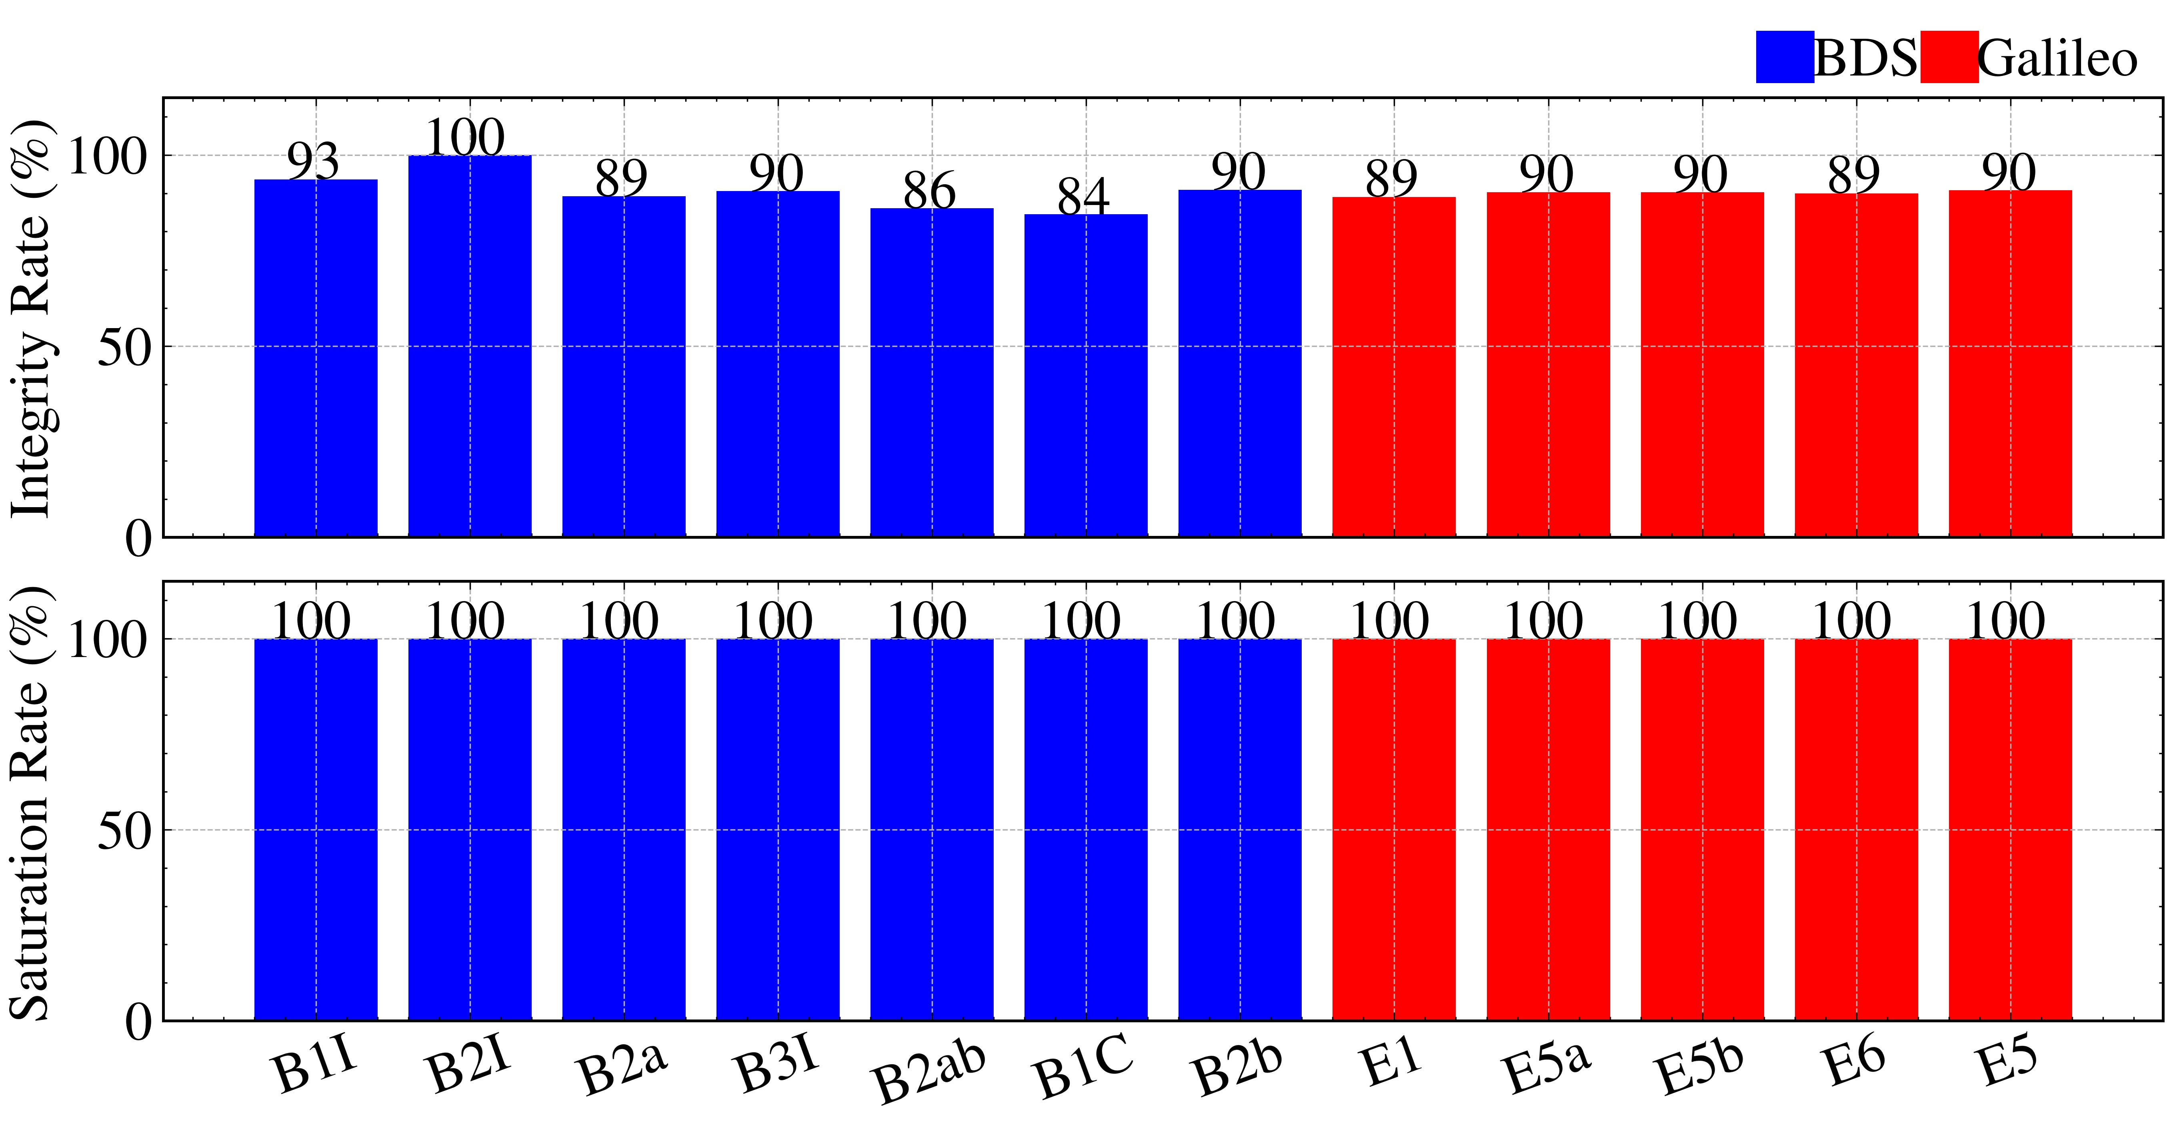

Fig. 21 Statistics result of data integrity and saturation rate for two systems

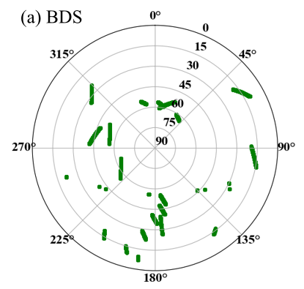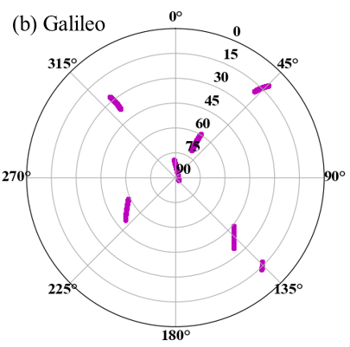

Fig. 22 Sky view of all satellites for two systems

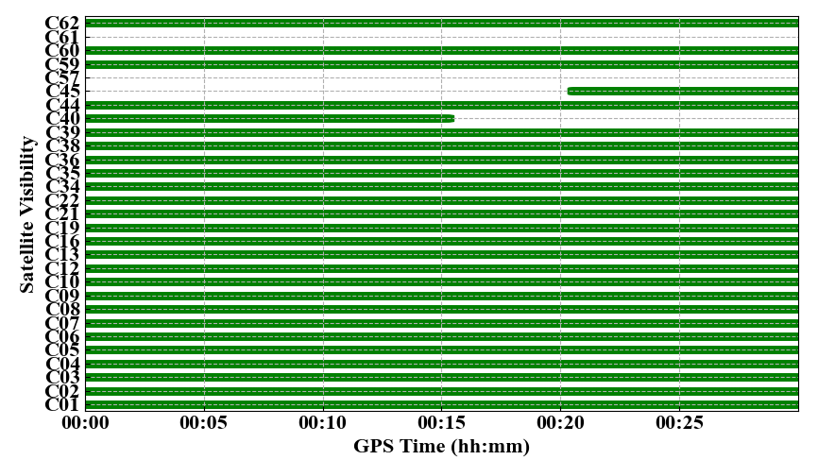

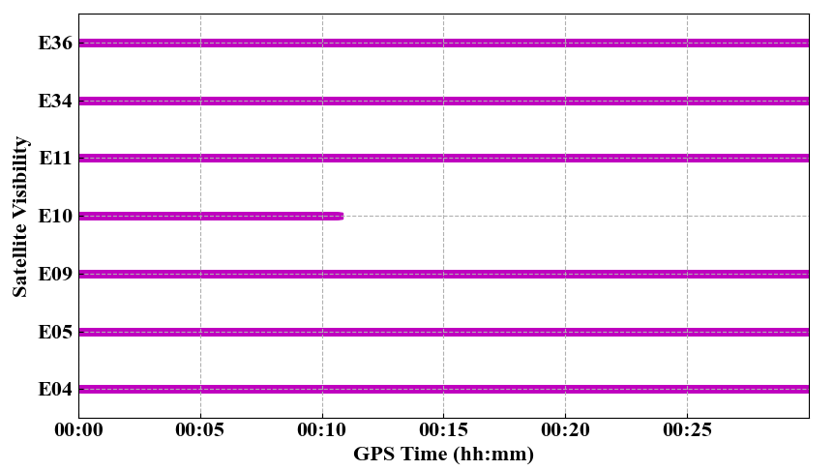

Fig. 23 Observation sequences of all satellites for two systems

**6 Mathematical methods**

The basic undifferenced observations of the original pseudorange and phase can be given as follows:

 (1)

where *s* denotes a specific satellite; *r* denotes receiver;  denotes the satellite-to receiver range (m); *c* denotes light velocity (m/s)； and  denote receiver and satellite clock offsets (s), respectively;  and  denote the wet mapping function and the zenith troposphere wet delay, respectively;  denotes the frequency correlation coefficient ();  denotes the slant ionospheric delay (m);  and  denote the wavelength and the integer phase ambiguity, respectively;  and  denote the frequency-dependent receiver and satellite code biases, respectively (s); and  denote the frequency-dependent receiver and satellite phase biases, respectively (s);  and  denote the sum of measurement noise and other unmodeled error for pseudorange and phase observations, respectively.

6.1 Pseudorange gross error detection

The commonly used pseudorange observations are *P*1, *P*2,and *C*1 codes. By using differential methods, then construct the following pseudorange gross error test quantity:

 (2)

 (3)

where, ,  and  denote the receiver and satellite differential code bias, respectively;  and  denote the time variable of differential code bias;  denotes the ionospheric delay residual error term between two frequencies;  and  denote the remaining error of combination. The combined detection quantity of  and  is detected:

 (4)

where *k*1 and *k*2 denote the test threshold. Generally, *k*1 and *k*2 are 30m and 60m.

6.2 Cycle slip detection

6.2.1 MW combination

The Melbourne-Wunnema (MW) combination is the difference between the wide-lane phase and narrow-lane pseudorange combination, and its expression is:

 (5)

where  and  denote the signal frequency; denote .

When there is no cycle slip, the value of *NW* has no significant difference. Therefore, the cycle slip test quantity is constructed as follows:

 (6)

The average wide-lane ambiguity and root mean square at each epoch are calculated according to the recursive formula:

 (7)

 (8)

wheredenotes the average value of wide lane ambiguity; denotes the variance.

If Eq. (9) is satisfied, cycle slips occur; gross errors occur if Eq. (10) is satisfied. Take the previous *i*-1 epochs as a segment, record its value of  and variance of  for subsequent processing, and divide it into a new segment from the epoch .

 (9)

 (10)

6.2.2 GF combination

The linear combination of Geometry-Free (GF) is defined by the following equation:

 (11)

where *e* denotes the carrier phase combination observation noise. The detection expression is as follows:

 (12)

where *k* denotes 4; denotes 0.4m/h.

6.3 Clock jump detection and repair

The deviation between the receiver and the satellite clock accumulates over time. To maintain synchronization, it is necessary to insert clock jumps into the receiver clock. Therefore, it is essential to detect and repair clock jumps by using the difference method between adjacent observation epochs:

 (13)

where *t* denotes epoch. Construct the detection quantity and its conditional equation:

 (14)

where *k*1 denotes the detection threshold. For epoch *t*, only when all satellites satisfy the test condition Eq. (14), it is considered that the clock jump occurs in this epoch or all satellites have a large cycle slip, then use Eq. (15) to calculate the clock jump candidate, and Eq. (16) to determine the actual clock jump *J*.

 (15)

 (16)

where α denotes the coefficient factor; *k*2 denotes the threshold.

After detecting and calculating *J*, the clock jump can be repaired in reverse. The corresponding calculation expression is:

 (17)

where  denotes the observations of the repaired carrier phase.

6.4 Data integrity rate

The data integrity rate is one of the essential indicators to measure the availability and completeness of receiver observation files. It mainly tests the number of lost observation epochs, reflecting the performance of receiver data reception and the impact of the surrounding environment on data reception. The data integrity rate is the ratio of actual epoch numbers with pseudorange and carrier phase values at the *i* frequency of satellite *s* to the theoretical number. Its expression is:

 (18)

where *n* denotes the number of all visible satellites within a certain period of time; and  denote the actual received data and the theoretical received data, respectively.

6.5 Data saturation rate

The data saturation rate is the minimum to maximum data amount ratio in different data types (pseudorange and carrier phase observations). Its expression is:

 (19)

where  denotes the number of observations of various types on the i frequency of satellite *s*.

6.6 Pseudorange multipath

Pseudorange multipath is related to the station environment. When dual-frequency observations are available, a combination of single-frequency pseudorange and dual-frequency carrier phase observations calculates pseudorange multipath as follows:

 (20)

where  and  denote the computational amount including multipath error and integer ambiguity on the *i* and *j* frequencies, respectively.

For the epoch intervals with continuous observation and no cycle slips, the integer ambiguity is a constant, and the pseudorange multipath error can be calculated by Eq. (21).

 (21)

where  denotes smoothing in the time domain.

6.7 Carrier phase multipath

Some satellite systems provide three-frequency and above carrier phase observations, using two dual-frequency ionosphere-free combinations to calculate carrier phase multipath; the corresponding expression is:

 (22)

6.8 Ionospheric delay rate

The ionospheric delay rate refers to the change in ionospheric delay per unit of time. When dual-frequency observations are available, the ionospheric delay rate can be calculated by using the difference method between adjacent epochs expressed as follows:

 (23)

 (24)

where *IODi* and *IODj* denote the ionosphere delay rate on the *i* and *j* frequencies, respectively.

6.9 Carrier-to-noise ratio

The carrier-to-noise ratio value (C/N0) is the ratio between signal strength and noise. It is mainly affected by the antenna gain parameter, the state of the correlator in the receiver, and the multipath effect. C/N0 can be obtained directly from the station's original observation data. The lower the value of C/N0, the higher the noise intensity and the worse the signal quality.

6.10 Pseudorange observation noise

Pseudorange observation noise not only reflects the quality of the satellite signal but also reflects the overall performance of the receiver. The pseudorange noise is calculated using the difference method between adjacent epochs, and its expression is:

 (25)

 (26)

where *n* denotes the number of satellites; *N* denotes the number of observations;  denotes the estimation of pseudorange observation noise.

6.11 Carrier phase observation noise

Similar to pseudorange noise calculation, the carrier phase noise is calculated using the difference method between adjacent epochs, and its expression is:

 (27)

 (28)

where  denotes the estimation of carrier phase observation noise.

6.12 Dilution of precision

The Dilution of Precision (DOP) reflects the positioning performance and the satellite's spatial distribution status. The smaller the DOP value, the better the spatial geometric distribution of the observation satellites and the smaller the positioning error, and its expression is:

 (29)

 (30)

 (31)

 (32)

where *Ai* denotes the the satellite azimuth; *Ei* denotes the satellite elevation; *n* denotes the number of satellites; *G* denotes observation matrix; *Q* denotes cofactor matrix; *GDOP* denotes geometric dilution precision; *PDOP* denotes position dilution precision.

**Acknowledgement**

Thank Mr. Tim Everett for the open-source rtklib-py program, which has provided us with reference and inspiration.